UNITED STATES

SECURITIES AND EXCHANGE COMMISSION
WASHINGTON, DC 20549

___________________

FORM 8-K

CURRENT REPORT

PURSUANT TO SECTION 13 OR 15(d) OF THE

SECURITIES EXCHANGE ACT OF 1934

Date of report (Date of earliest event reported): February 8, 2019

ARCTURUS THERAPEUTICS LTD.

(Exact Name of Registrant as Specified in Charter)

State of Israel

(State or Other Jurisdiction of Incorporation)

001-35932

(Commission File Number)

Not applicable

(I.R.S. Employer Identification No.)

10628 Science Center Drive, Suite 250

San Diego, California

(Address of Principal Executive Offices)

92121

(Zip Code)

Registrant’s telephone number, including area code: (858) 900-2660

Check the appropriate box below if the Form 8-K filing is intended to simultaneously satisfy the filing obligation of the registrant under any of the following provisions (see General Instruction A.2. below):

o Written communications pursuant to Rule 425 under the Securities Act (17 CFR 230.425).

o Soliciting material pursuant to Rule 14a-12 under the Exchange Act (17 CFR 240.14a-12).

o Pre-commencement communications pursuant to Rule 14d-2(b) under the Exchange Act (17 CFR 240-14d-2(b)).

o Pre-commencement communications pursuant to Rule 13e-4(c) under the Exchange Act (17 CFR 240-13e-4(c)).

Indicate by check mark whether the registrant is an emerging growth company as defined in as defined in Rule 405 of the Securities Act of 1933 (§230.405 of this chapter) or Rule 12b-2 of the Securities Exchange Act of 1934 (§240.12b-2 of this chapter).

Emerging growth company ☒

If an emerging growth company, indicate by check mark if the registrant has elected not to use the extended transition period for complying with any new or revised financial accounting standards provided pursuant to Section 13(a) of the Exchange Act. ☐

Item 7.01

Regulation FD Disclosure.

Arcturus Therapeutics Ltd. (the “Company”) has made available a presentation about the Company’s business (the “Presentation”), a copy of which is filed as Exhibit 99.1 to this Current Report on Form 8-K (the “Report”) and is hereby incorporated by reference.

The furnishing of the Presentation is not an admission as to the materiality of any information therein. The information contained in the Presentation is summary information that should be considered in the context of the Company’s filings with the Securities and Exchange Commission (the “SEC”) and other public announcements the Company may make by press release or otherwise from time to time. The Presentation speaks as of the date of this Report. While the Company may elect to update the Presentation in the future to reflect events and circumstances occurring or existing after the date of this Report, the Company specifically disclaims any obligation to do so.

The Presentation contains forward-looking statements, and as a result, investors should not place undue reliance on these forward-looking statements.

The information set forth in this Item 7.01 or the Presentation is not deemed “filed” for purposes of Section 18 of the Securities Exchange Act of 1934, as amended (the “Exchange Act”), or incorporated by reference in any filing under the Securities Act of 1933, as amended, or the Exchange Act, except as may be expressly set forth by specific reference in such a filing.

Item 8.01

Other Events.

On February 11, 2019, the Company issued a press release, a copy of which is furnished herewith as Exhibit 99.2, announcing the termination of the obligations of Curevac AG for the preclinical development of ARCT-810, effective 180 days from February 5, 2019 and the re-assumption by the Company of the worldwide rights thereto.

On February 8, 2019, the Company entered into a share exchange agreement between the Company and a special-purpose company, Arcturus Therapeutics Holdings Inc. (“NewCo”) (the “Share Exchange Agreement”) in connection with the contemplated redomestication of the Company from Israel to Delaware (the “Redomestication”). Pursuant to the Share Exchange Agreement, and in order to effectuate the transactions contemplated by the Share Exchange Agreement, on February 11, 2019, the Company filed an application with the Tel Aviv District Court to approve the convening of a general shareholders meeting of the Company for the approval of the Redomestication pursuant to Sections 350 and 351 of the Companies Law, 1999-5759 (the "Companies Law"). The Share Exchange Agreement and the Redomestication are subject to shareholder approval as required by the Companies Law, Israeli court approval, effectiveness of filings to be made with the SEC, approval of the listing of shares of NewCo by the NASDAQ Stock Market LLC (“Nasdaq”) and the other conditions precedent set forth in the Share Exchange Agreement (the “Conditions Precedent”).

In furtherance of the Redomestication, the holders of ordinary shares of the Company as of a future record date and the holders of options to purchase ordinary shares of the Company as of the same record date will transfer their ordinary shares of the Company and options to purchase ordinary shares of the Company, respectively, to NewCo and, in exchange thereof, will receive one share of common stock of NewCo for each ordinary share of the Company and one option to purchase one share of common stock of NewCo in exchange for each option to purchase an ordinary share of the Company, respectively.

Concurrently, the Company intends the common stock of NewCo to be listed on NASDAQ. Upon consummation of the transactions contemplated by the Share Exchange Agreement, it is expected that the Company’s ordinary shares will be delisted from trading on NASDAQ, and the Company is expected to become a private company (as defined in the Companies Law) wholly-owned by NewCo.

Pursuant to the Share Exchange Agreement, the Company also agreed, subject to the Conditions Precedent set forth therein, to transfer all of the shares of Arcturus Therapeutics Inc. (“Arcturus Sub”), a wholly-owned subsidiary of the Company, to NewCo through a reduction of the Company’s equity and the distribution of a dividend-in-kind, such that Arcturus Sub and the Company shall each become a wholly-owned and direct subsidiary of NewCo.

Cautionary Note Regarding Forward-Looking Statements

Certain statements in this communication, including statements relating to the Share Exchange Agreement, the Redomestication, the achievement of the Conditions Precedent, the transactions contemplated by the Share Exchange Agreement and the Company’s, NewCo’s or Arcturus Sub’s future ownership, capitalization, listing status, financial condition, performance, operating results, strategy and plans are “forward-looking statements” within the meaning of the Private Securities Litigation Reform Act of 1995 giving the Company’s expectations or predictions of future financial or business performance or conditions. These forward-looking statements are subject to numerous assumptions, risks and uncertainties which change over time. Forward-looking statements speak only as of the date they are made and the Company, NewCo and Arcturus Sub assume no duty to update forward-looking statements, except as required by law.

In addition to factors previously disclosed in the Company’s reports filed with the SEC and those identified elsewhere in this communication, the following factors, among others, could cause actual results to differ materially from forward-looking statements and historical performance: our ability to obtain approval of the Company’s ordinary shareholders and the approval of the Tel Aviv District Court for the Redomestication, our ability to obtain the necessary governmental and regulatory approvals, our ability to satisfy the Conditions Precedent within the expected time frame or at all, our ability to realize the expected benefits from the Redomestication, the occurrence of difficulties in connection with the Redomestication, any unanticipated costs in connection with the Redomestication, the ability to effect the proposed Redomestication, adverse tax consequences to shareholders from the Redomestication, disruption following the Redomestication; the availability and access, in general, of funds to fund operations and necessary capital expenditures.as well as our management’s response to these factors. The foregoing factors are in addition to the other factors set forth in the Company’s reports on Form 20-F, Form 6-K, and other documents on file with the SEC.

Other risks and uncertainties are more fully described in the Company’s Annual Report on Form 20-F for the year ended December 31, 2017 and Amendment No. 1 thereto, each filed with the SEC, and in other filings that the Company makes and will make with the SEC in connection with the Redomestication. Existing and prospective investors are cautioned not to place undue reliance on these forward-looking statements, which speak only as of the date hereof. The statements made in this Current Report on Form 8-K and the exhibit(s) attached hereto speak only as of the date stated herein, and subsequent events and developments may cause the Company’s expectations and beliefs to change. While the Company may elect to update these forward-looking statements publicly at some point in the future, the Company specifically disclaims any obligation to do so, whether as a result of new information, future events or otherwise, except as required by law. These forward-looking statements should not be relied upon as representing the Company’s views as of any date after the date stated herein.

Item 9.01 Financial Statements and Exhibits.

Exhibit Number |  | Description
99.1 |  | Presentation of Arcturus Therapeutics Ltd., dated February 11, 2019
99.2 |  | Press Release of Arcturus Therapeutics Ltd., dated February 11, 2019

SIGNATURES

Pursuant to the requirements of the Securities Exchange Act of 1934, the Registrant has duly caused this report to be signed on its behalf by the undersigned hereunto duly authorized.

ARCTURUS THERAPEUTICS LTD.

By: /s/ Joseph E. Payne

Joseph E. Payne

Chief Executive Officer

Dated: February 11, 2019

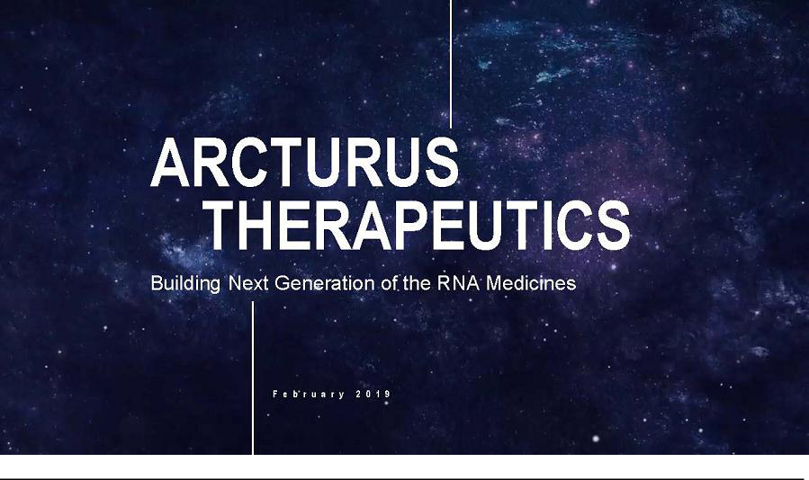

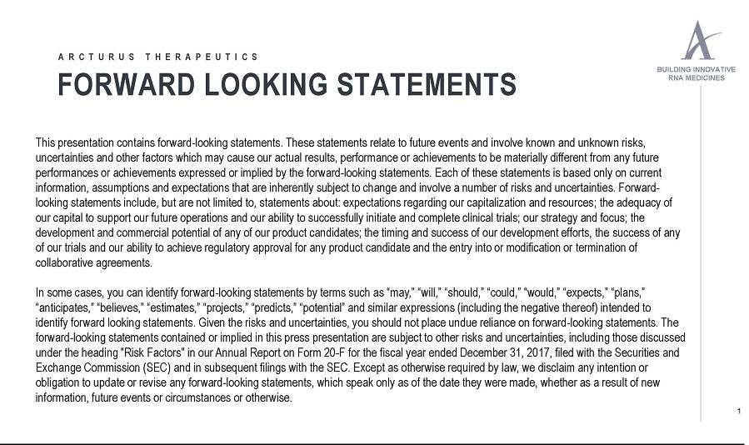

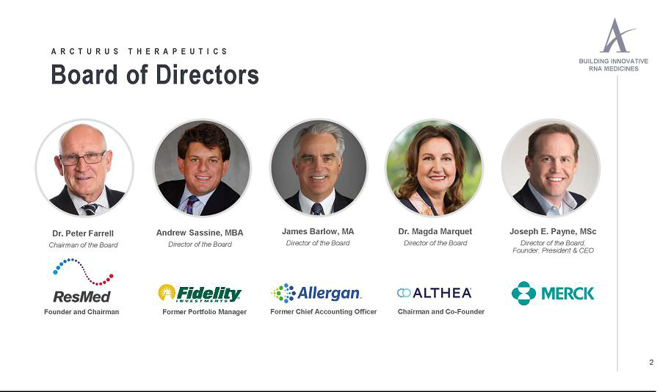



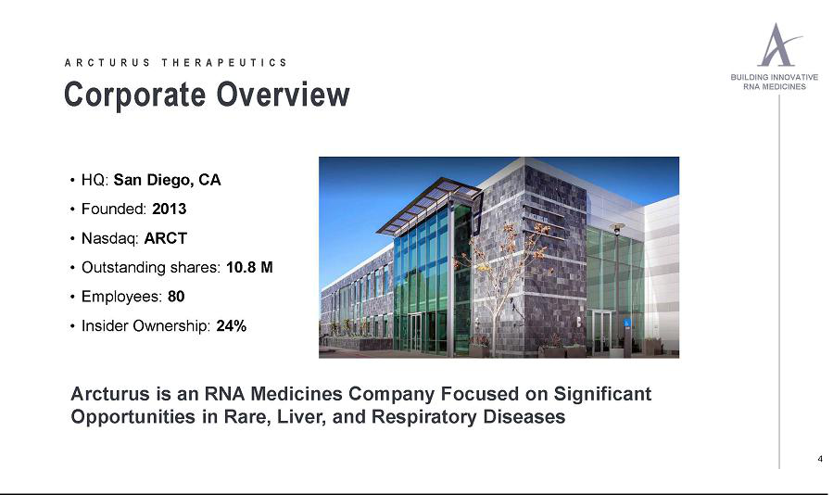

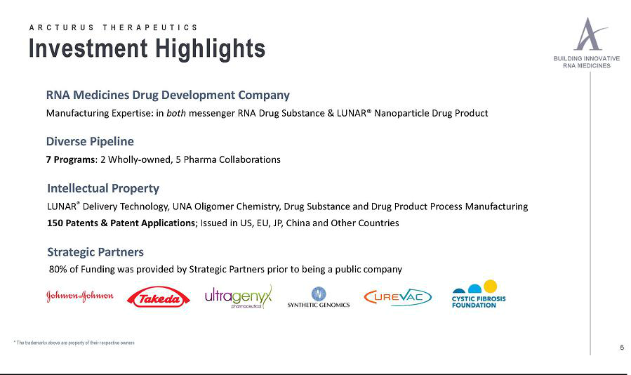

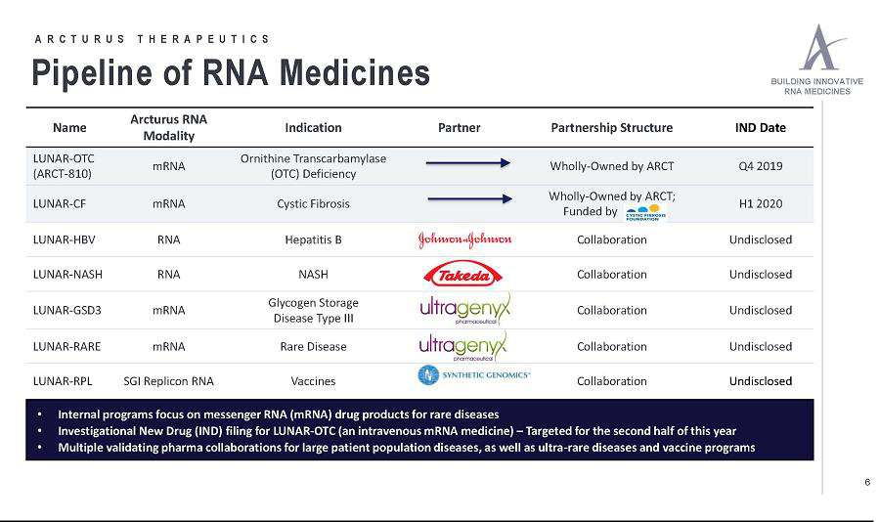

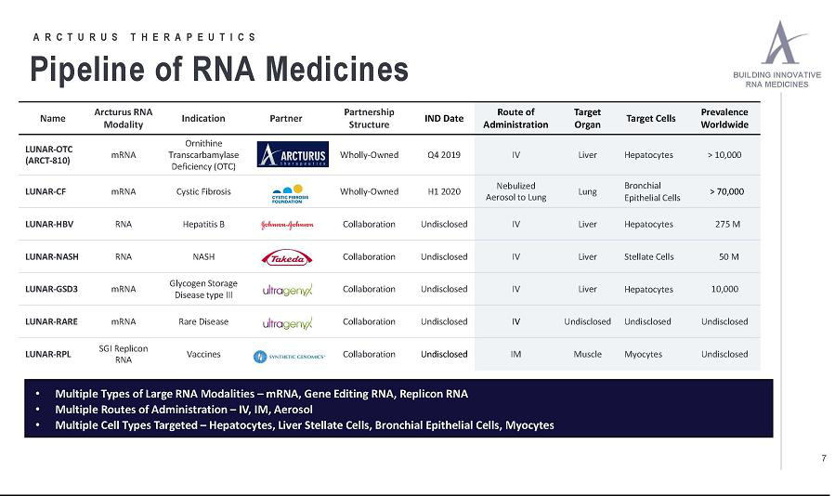

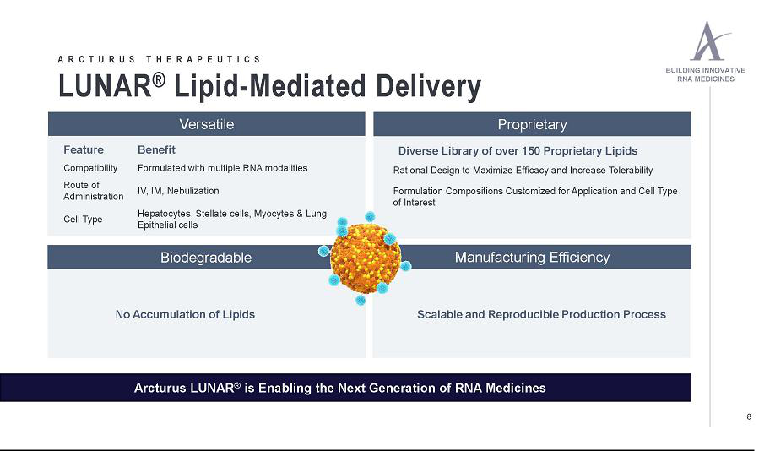

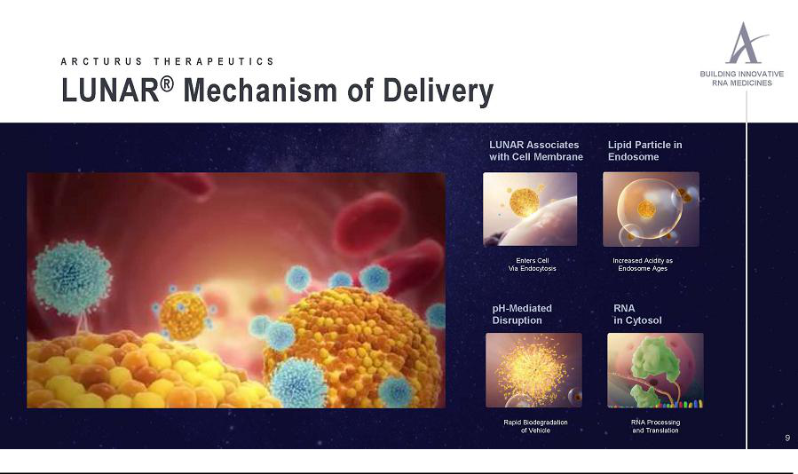

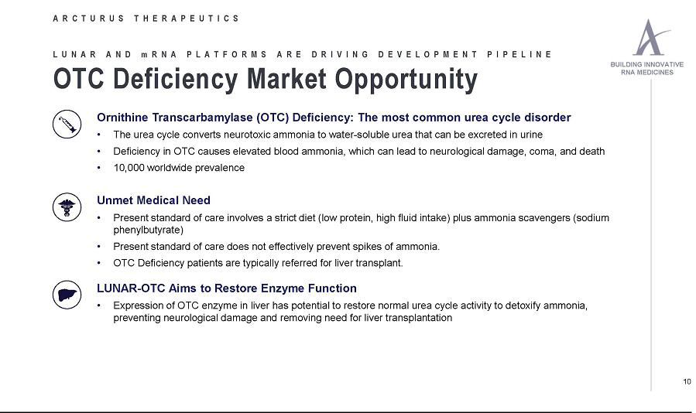

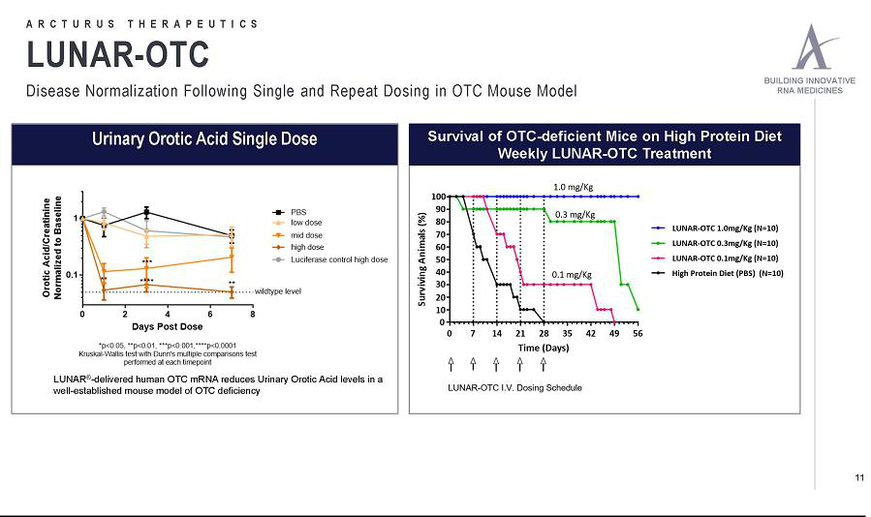

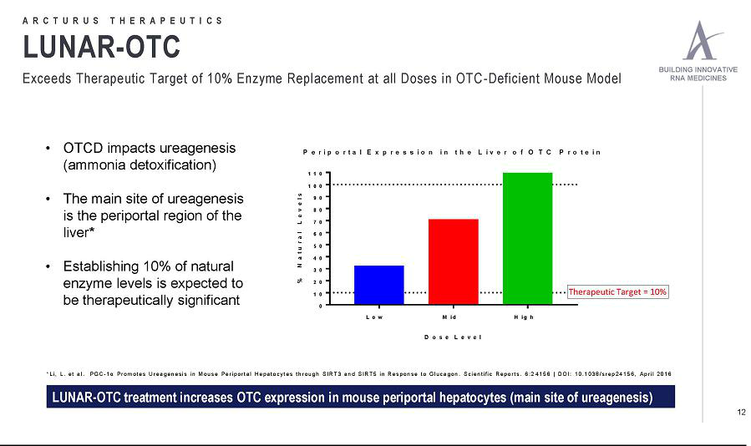

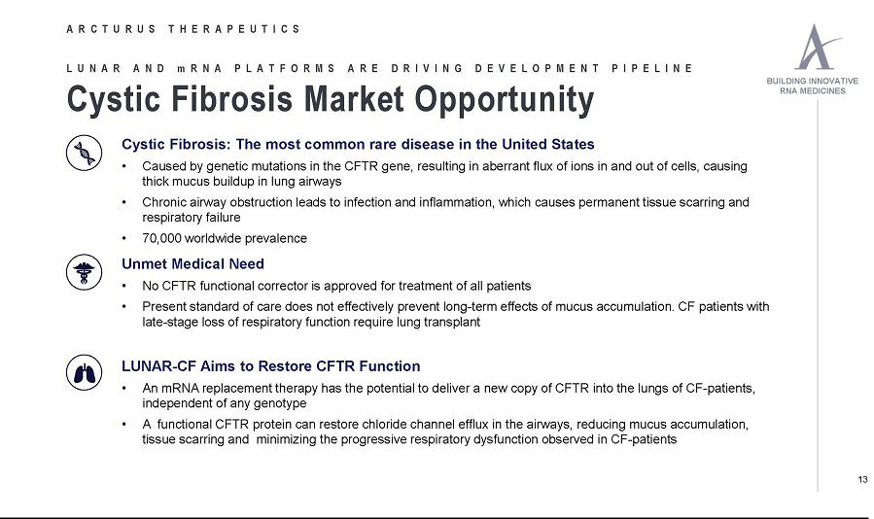

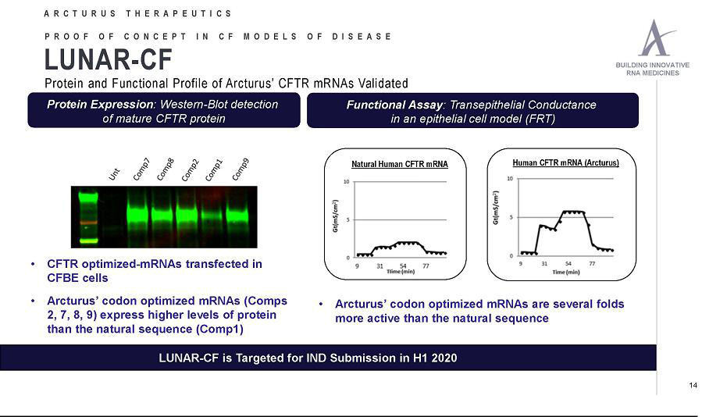

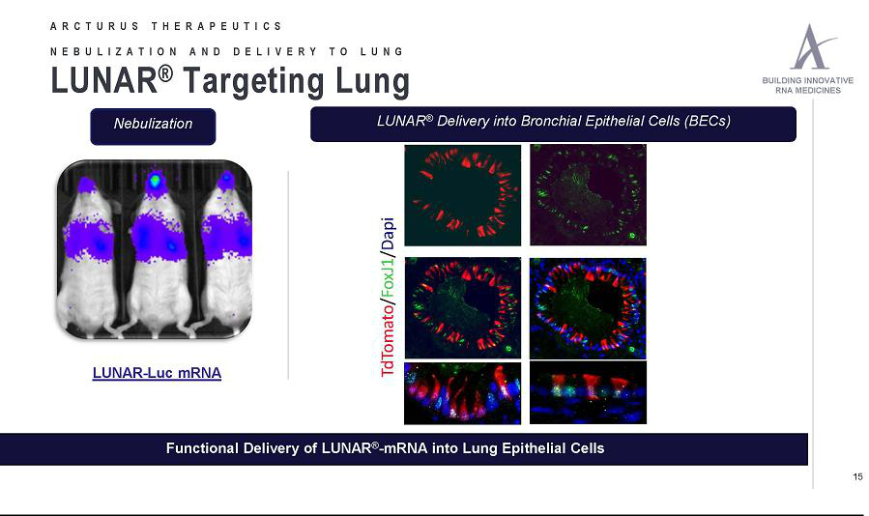

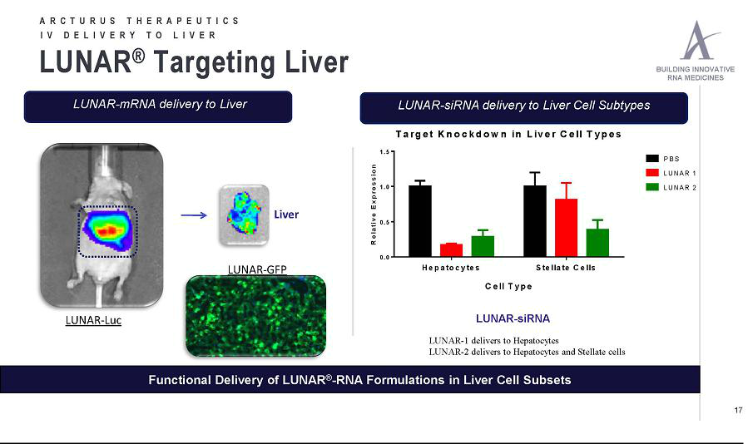

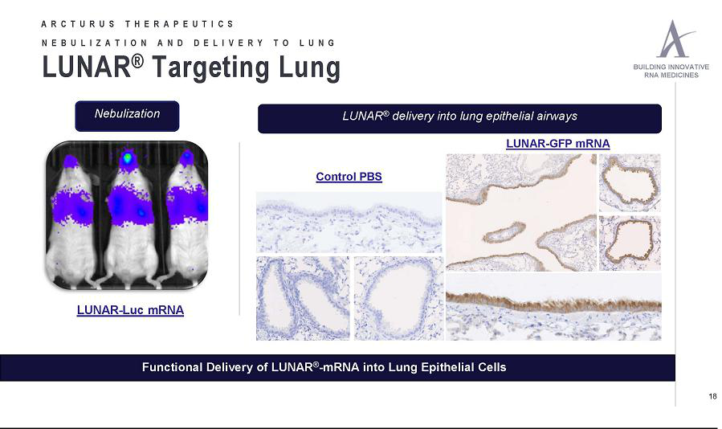

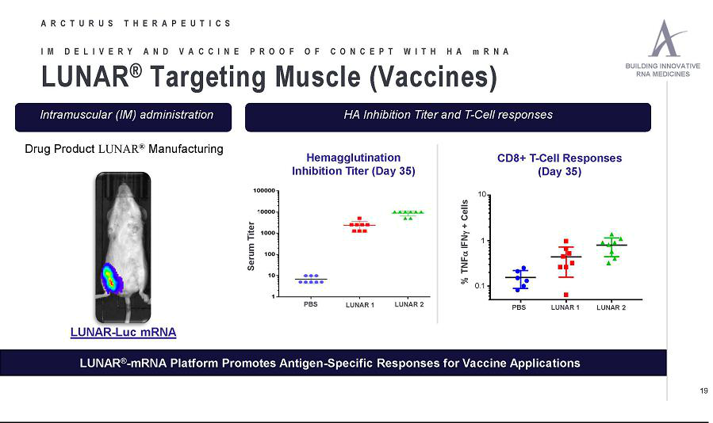

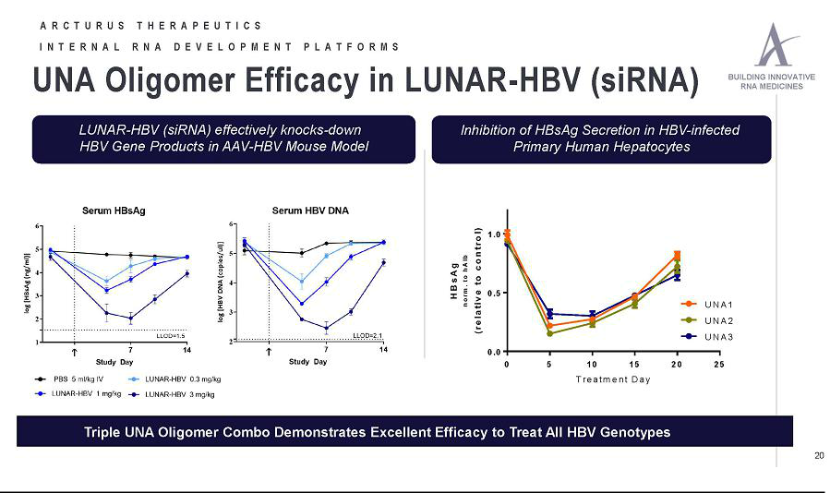

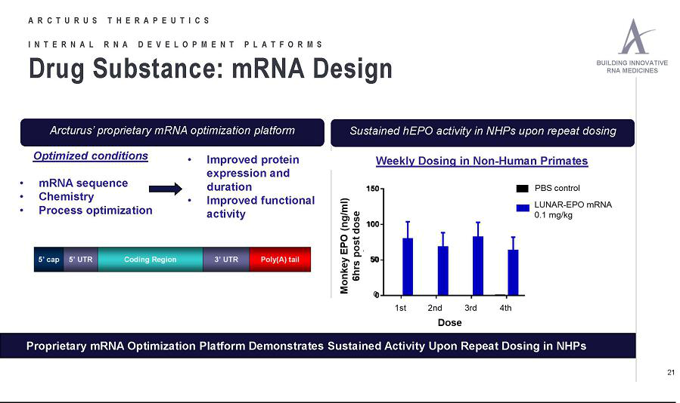

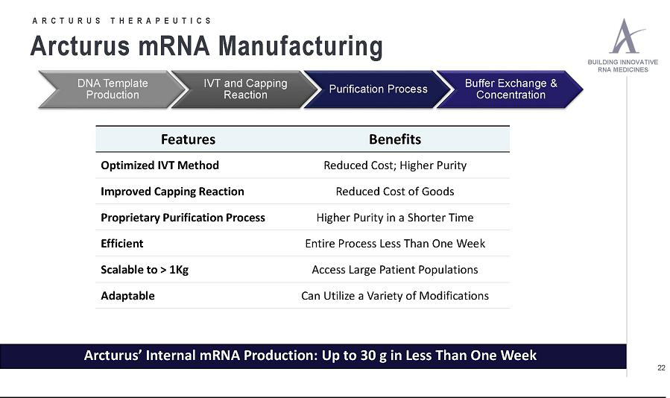

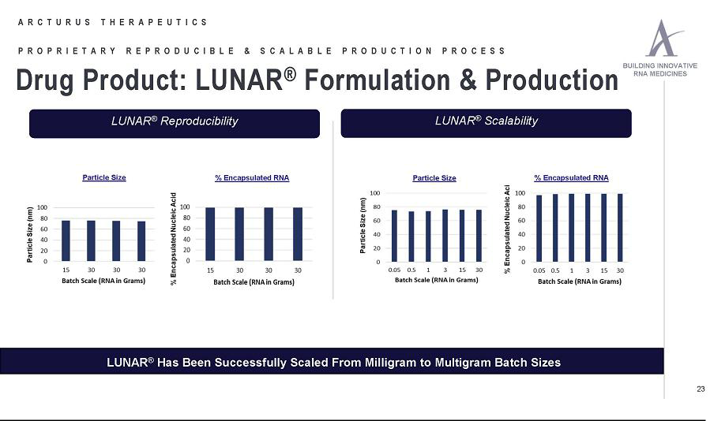



Exhibit 99.2

Arcturus Therapeutics Reassumes Full Worldwide Rights to ARCT-810, a Clinical Development Candidate for Ornithine Transcarbamylase (OTC) Deficiency

San Diego, CA – Feb. 11, 2019 – Arcturus Therapeutics Ltd. (NASDAQ: ARCT), a leading RNA medicines company focused on the discovery, development and commercialization of therapeutics towards rare diseases, today announced that it will reassume 100% global rights for its flagship asset, clinical development candidate ARCT-810, a messenger RNA (mRNA) drug to treat OTC Deficiency. ARCT-810 was previously subject to a 50/50 collaboration between Arcturus and CureVac AG. CureVac elected not to continue its obligations for the preclinical development of ARCT-810 under and pursuant to the terms of the collaboration.

The preclinical development program for ARCT-810, including Investigational New Drug Application (IND) enabling studies, remains on track. Arcturus is planning to file an IND for ARCT-810 with the U.S. Food and Drug Administration (FDA) in the fourth quarter of 2019.

CureVac remains committed to developing additional assets within the Arcturus collaboration utilizing CureVac mRNA and Arcturus LUNAR® delivery technology.
CureVac and Arcturus will announce when the next program has been selected.

“We have had a very productive collaboration with CureVac on ARCT-810 and are pleased that we have secured all of the rights to this clinical development candidate. We are enthusiastic about the value of ARCT-810 and we believe it has the potential to be a transformational treatment for patients suffering from OTC deficiency,” said Joseph Payne, President & CEO of Arcturus. “Importantly, Arcturus has the resources and expertise to advance this program into the clinic. We are pursuing an aggressive development timeline with an IND filing planned for this year. We look forward to our continued collaboration with CureVac to advance therapies for patients in need of potential new treatment options..”

Arcturus plans to present further data and updates on the progress of ARCT-810 at the “TIDES: Oligonucleotide & Peptide Therapeutics” conference, to take place May 20th to 23rd, 2019 in San Diego, CA.

About ARCT-810

ARCT-810, Arcturus’ first development candidate, represents a novel approach to treat ornithine transcarbamylase deficiency (OTCD). ARCT-810 is based on mRNA and also utilizes Arcturus’ propriety lipid library and employs the Company's LUNAR® delivery platform to safely and effectively deliver OTC mRNA to hepatocytes. ARCT-810 is an mRNA replacement therapy designed to enable OTC-deficient patients to naturally produce healthy functional OTC enzyme in their own liver cells. Arcturus is currently on track to submit an Investigational New Drug Application (IND) to the FDA in the fourth quarter of 2019. ARCT-810 is advancing toward the clinic on the strength of preclinical proof-of-concept data, demonstrating that LUNAR technology can deliver mRNA to liver cells and results in expression of functional OTC protein in animal models. Replacing the deficient OTC protein restores the urea cycle pathway, resulting in reduced plasma ammonia and urinary orotate concentrations.

About Ornithine Transcarbamylase Deficiency (OTCD)

OTC deficiency is caused by mutations in the OTC gene which leads to a non-functional or deficient OTC enzyme. OTCD is the most common urea cycle disorder. Urea cycle disorders are a group of inherited metabolic disorders that make it difficult for afflicted patients to remove toxic waste products, as proteins are digested. OTC deficiency is a life-threatening genetic disease. OTC is a critical enzyme in the urea cycle, which takes place in liver cells, and converts ammonia to urea. This conversion does not occur properly in patients with OTC deficiency and ammonia accumulates in their blood, acting as a neurotoxin and liver toxin. This can cause severe symptoms including vomiting, headaches, coma and death. OTC deficiency is an inherited disease that can cause developmental problems, seizures and death in newborn babies. It is an X-linked disorder, so is more common in boys. Patients with less severe symptoms may present later in life, as adults. There is currently no cure for OTC deficiency, apart from liver transplant. However, this treatment comes with significant risk of complications such as organ rejection, and transplant recipients must take immunosuppressant drugs for the rest of their lives. Current standard of care for OTC patients is a low-protein diet and ammonia scavengers to try and prevent patients from accumulating ammonia. These treatments do not address the underlying cause of disease.

About Arcturus Therapeutics Ltd.

Founded in 2013 and headquartered in San Diego, California, Arcturus Therapeutics Ltd. (NASDAQ: ARCT) is an RNA medicines company with enabling technologies – LUNAR® lipid-mediated delivery and UNA Oligomer chemistry. Arcturus’ diverse pipeline of RNA therapeutics includes programs pursuing rare diseases, Hepatitis B, non-alcoholic steatohepatitis (NASH), cystic fibrosis, and vaccines. Arcturus’ versatile RNA therapeutics platforms can be applied toward multiple types of nucleic acid medicines including messenger RNA, small interfering RNA, replicon RNA, antisense RNA, microRNA, DNA and gene editing therapeutics. Arcturus owns LUNAR lipid-mediated delivery and Unlocked Nucleomonomer Agent (UNA) technology including UNA Oligomers, which are covered by its extensive patent portfolio (150 patents and patent applications, issued in the U.S., Europe, Japan, China and other countries). Arcturus’ proprietary UNA technology can be used to target individual genes in the human genome, as well as viral genes, and other species for therapeutic purposes. Arcturus’ commitment to the development of novel RNA therapeutics has led to partnerships with Janssen Pharmaceuticals, Inc., part of the Janssen Pharmaceutical Companies of Johnson & Johnson, Ultragenyx Pharmaceutical, Inc., Takeda Pharmaceutical Company Limited, Synthetic Genomics Inc., CureVac AG and the Cystic Fibrosis Foundation. For more information, visit www.Arcturusrx.com, the content of which is not incorporated herein by reference.

Forward-Looking Statements

This press release contains “forward-looking statements” that involve substantial risks and uncertainties for purposes of the safe harbor provided by the Private Securities Litigation Reform Act of 1995. Any statements, other than statements of historical fact, included in this press release regarding strategy, future operations, collaborations, future financial position, prospects, plans and objectives of management, including statements relating to the status of the preclinical development program for ARCT-810, the date that an IND may be filed with the FDA, the potential for ARCT-810, are forward-looking statements. Arcturus may not actually achieve the plans, carry out the intentions or meet the expectations or projections disclosed in any forward-looking statements and you should not place undue reliance on such forward-looking statements. Actual results and performance could differ materially from those projected in any forward-looking statements as a result of many factors, including without limitation, an inability to develop and market product candidates. Such statements are based on management’s current expectations and involve risks and uncertainties, including those discussed under the heading “Risk Factors” in Arcturus’ Annual Report on Form 20-F for the fiscal year ended December 31, 2017, filed with the SEC on May 14, 2018 and in subsequent filings with, or submissions to, the SEC. Except as otherwise required by law, Arcturus disclaims any intention or obligation to update or revise any forward-looking statements, which speak only as of the date they were made, whether as a result of new information, future events or circumstances or otherwise.

Contact

Neda Safarzadeh

Arcturus Therapeutics

- 900-2682

IR@ArcturusRx.com

Arcturus Investor Contact

Michael Wood

LifeSci Advisors LLC

- 597-6983 mwood@lifesciadvisors.com

