UNITED STATES
SECURITIES AND EXCHANGE COMMISSION
Washington, D.C. 20549

FORM 8-K

CURRENT REPORT
Pursuant to Section 13 or 15(d)
of the Securities Exchange Act of 1934

Date of Report (Date of earliest event reported): September 23, 2026

ARCTURUS THERAPEUTICS HOLDINGS INC.
(Exact name of registrant as specified in its charter)

Delaware |  | 001-38942 |  | 32-0595345
(State or other jurisdiction  of incorporation) |  | (Commission  File Number) |  | (I.R.S. Employer  Identification No.)

10285 Science Center Drive
San Diego, California 92121
(Address of principal executive offices)

Registrant’s telephone number, including area code: (858) 900-2660

Check the appropriate box below if the Form 8-K filing is intended to simultaneously satisfy the filing obligation of the registrant under any of the following provisions:

☐ | Written communications pursuant to Rule 425 under the Securities Act (17 CFR 230.425)
☐ | Soliciting material pursuant to Rule 14a-12 under the Exchange Act (17 CFR 240.14a-12)
☐ | Pre-commencement communications pursuant to Rule 14d-2(b) under the Exchange Act (17 CFR 240.14d-2(b))
☐ | Pre-commencement communications pursuant to Rule 13e-4(c) under the Exchange Act (17 CFR 240.13e-4(c))

Securities registered pursuant to Section 12(b) of the Act:

Title of each class |  | Trading  Symbol(s) |  | Name of each exchange  on which registered
Common stock, par value $0.001 per share |  | ARCT |  | The Nasdaq Stock Market LLC

Indicate by check mark whether the registrant is an emerging growth company as defined in Rule 405 of the Securities Act of 1933 (§230.405 of this chapter) or Rule 12b-2 of the Securities Exchange Act of 1934 (§240.12b-2 of this chapter).

Emerging growth company ☐

If an emerging growth company, indicate by check mark if the registrant has elected not to use the extended transition period for complying with any new or revised financial accounting standards provided pursuant to Section 13(a) of the Exchange Act. ☐

Item 7.01. Regulation FD Disclosure.

On September 23, 2026, Arcturus Therapeutics Holdings Inc., a Delaware corporation (the “Company” or “Arcturus”) presented an overview of ARCT-810 Phase 2 clinical data, provided an update on its mRNA delivery platform (the “Presentation”) and issued a press release which summarizes the Presentation (the “Release”).

Copies of the Presentation and Release are furnished herewith as Exhibit 99.1 and Exhibit 99.2, respectively, and are incorporated into this Item 7.01 by reference.

The information in this Item 7.01 of this Current Report on Form 8-K, the Presentation and the Release, shall not be deemed “filed” for purposes of Section 18 of the Securities Exchange Act of 1934, as amended, or otherwise subject to the liabilities of that section or Sections 11 and 12(a)(2) of the Securities Act of 1933, as amended. The information contained in this Item 7.01, and in the Presentation and the Release, shall not be incorporated by reference into any filing with the Securities and Exchange Commission made by the Company, whether made before or after the date hereof, regardless of any general incorporation language in such filing.

Item 9.01 Financial Statements and Exhibits.

(d) Exhibits.

Exhibit No. | Description of Exhibit
99.1 | Presentation, dated September 23, 2026
99.2 | Press Release, dated September 23, 2026
104 | Cover Page to this Current Report on Form 8-K in Inline XBRL

SIGNATURES

Pursuant to the requirements of the Securities Exchange Act of 1934, the registrant has duly caused this report to be signed on its behalf by the undersigned hereunto duly authorized.

 | Arcturus Therapeutics Holdings Inc.
Date: September 23, 2026
 | By: | /s/ Joseph E. Payne
 | Name: | Joseph E. Payne
 | Title: | Chief Executive Officer

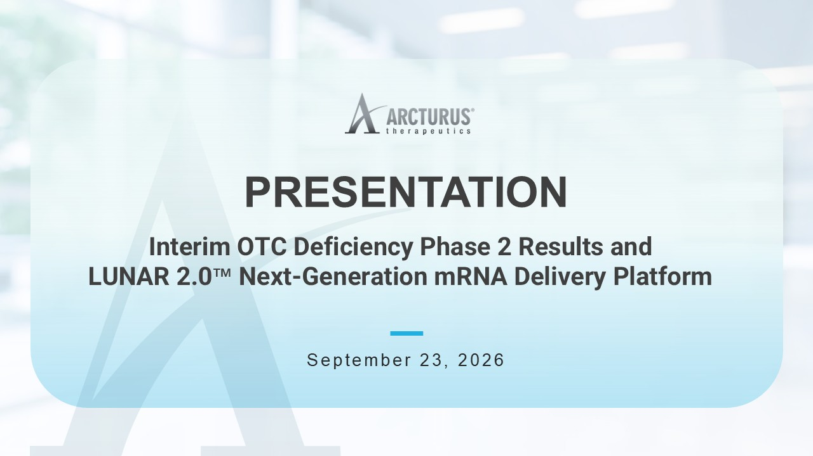

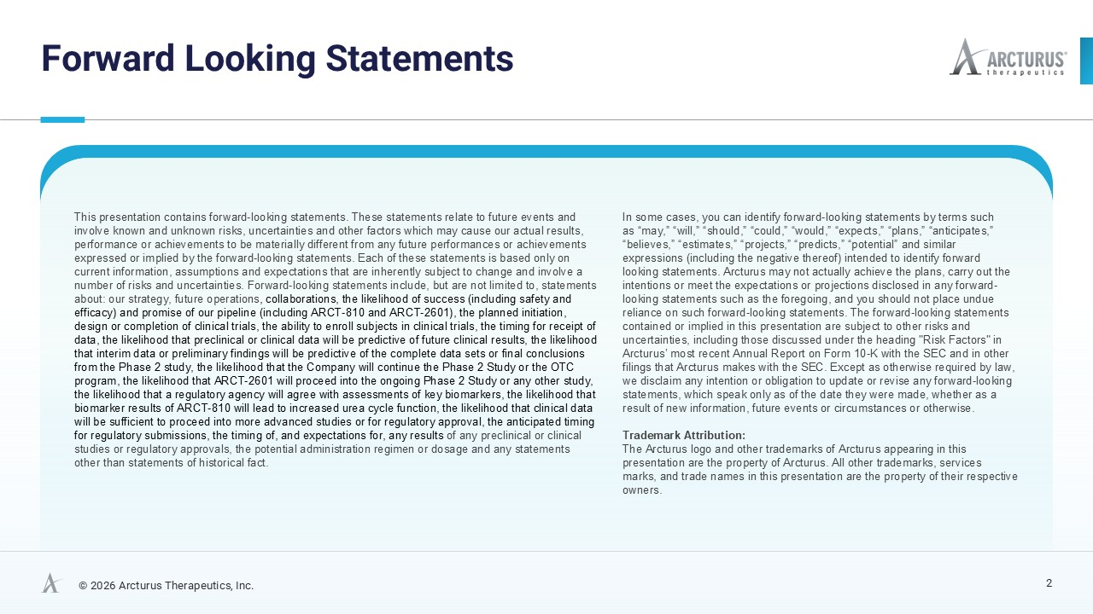

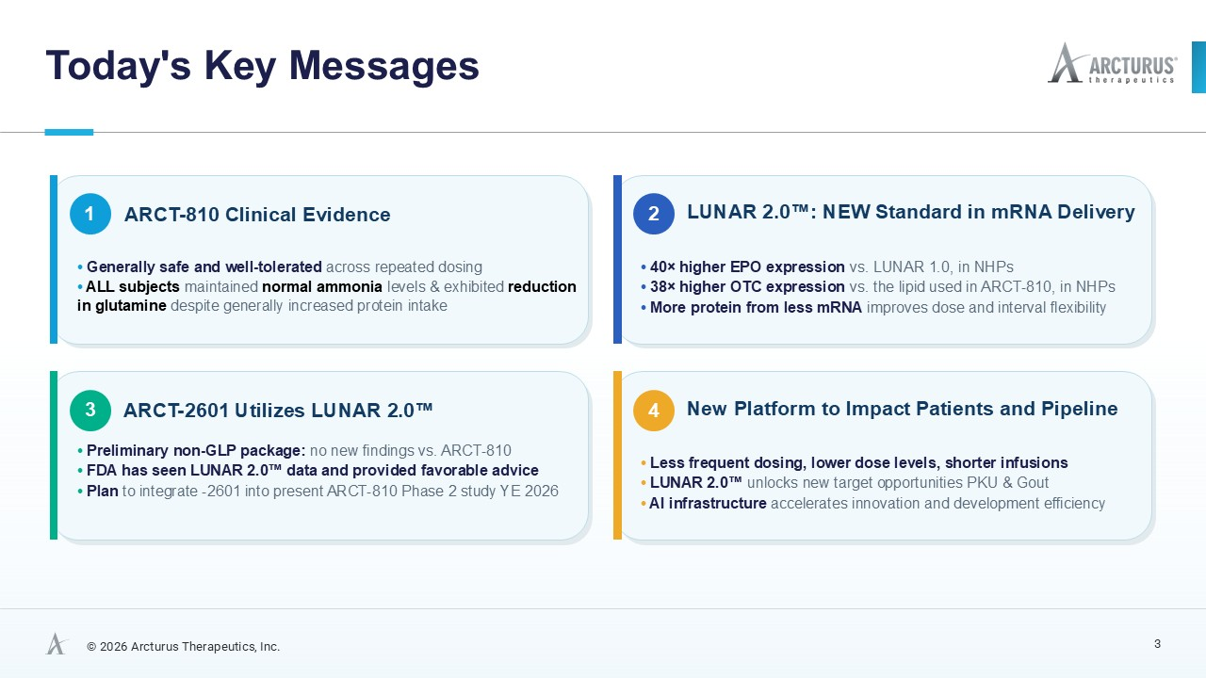

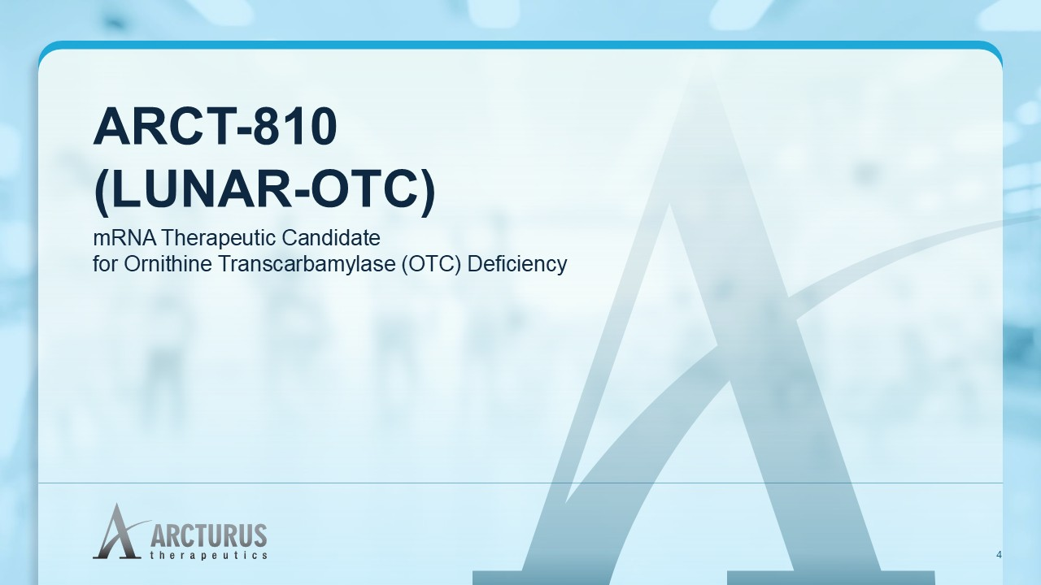

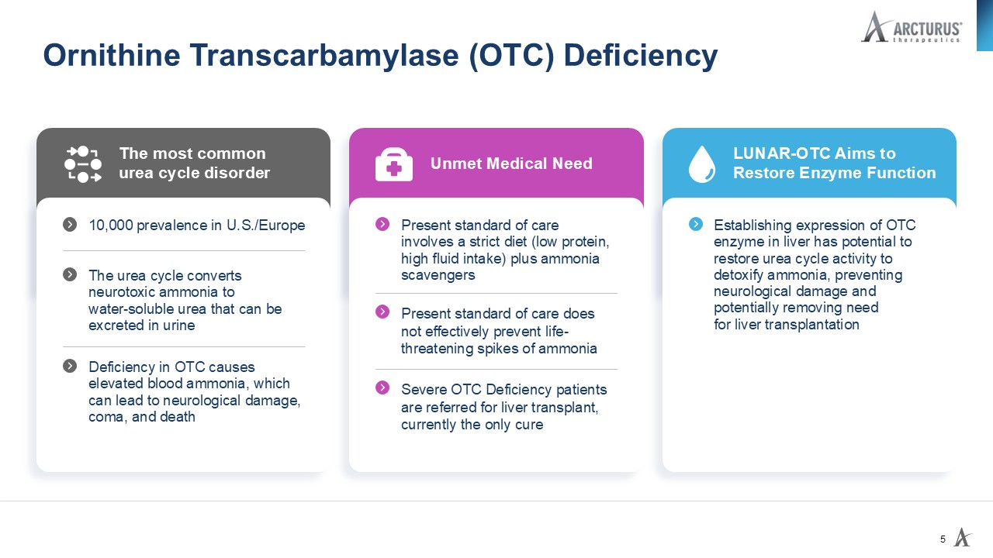

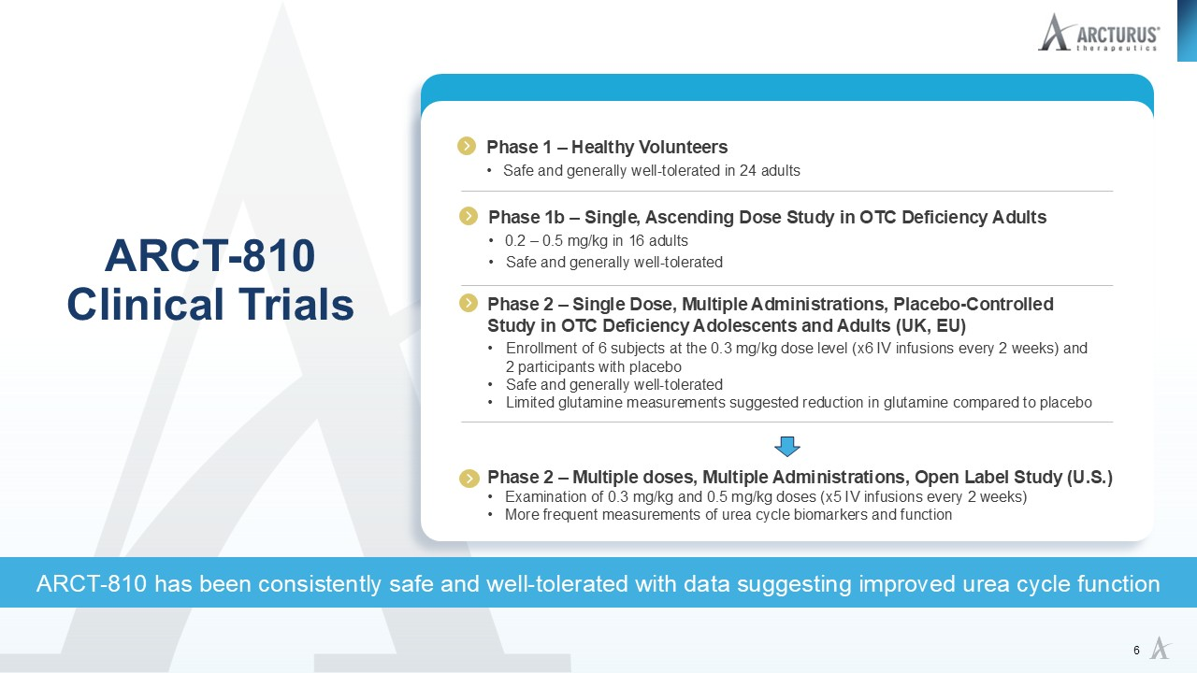

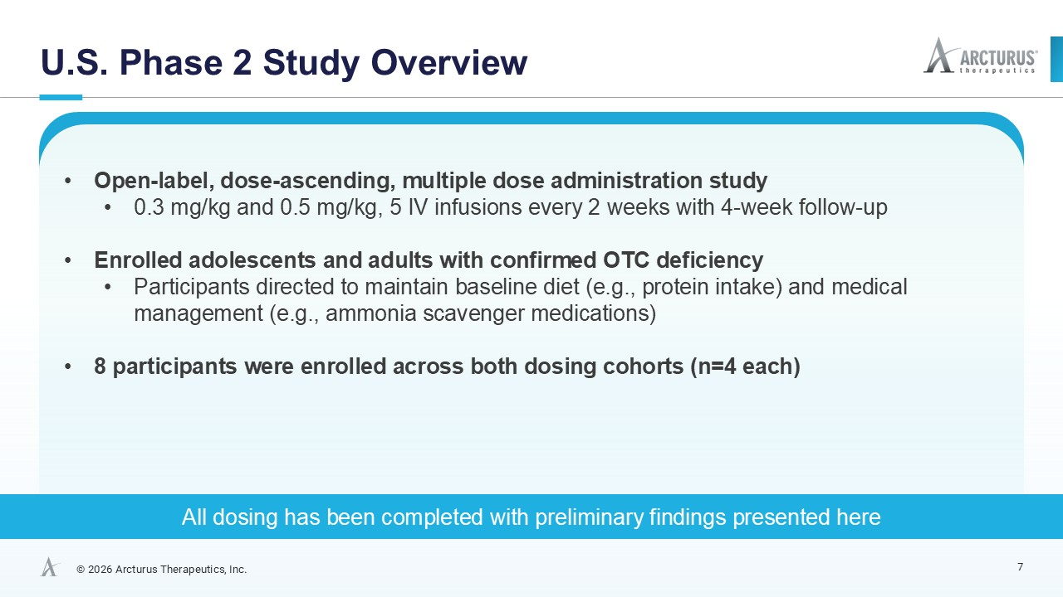

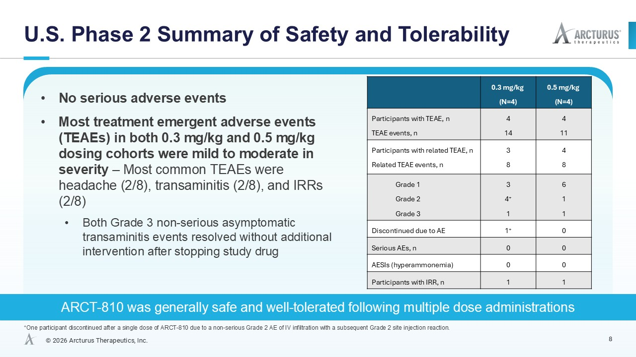

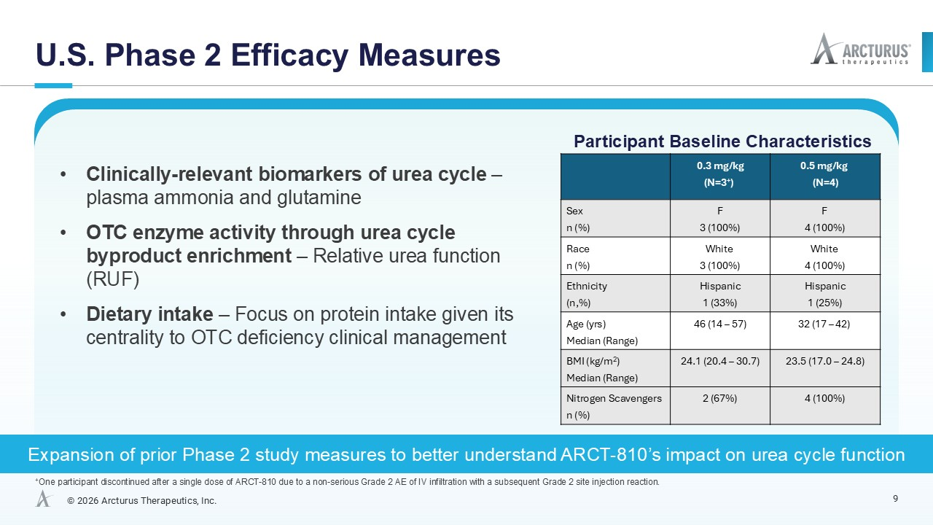

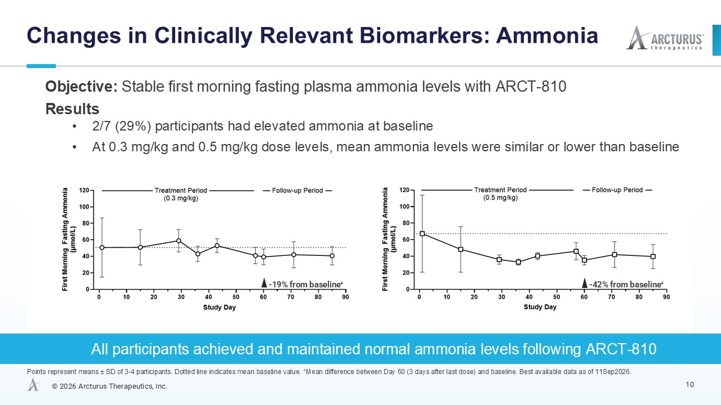

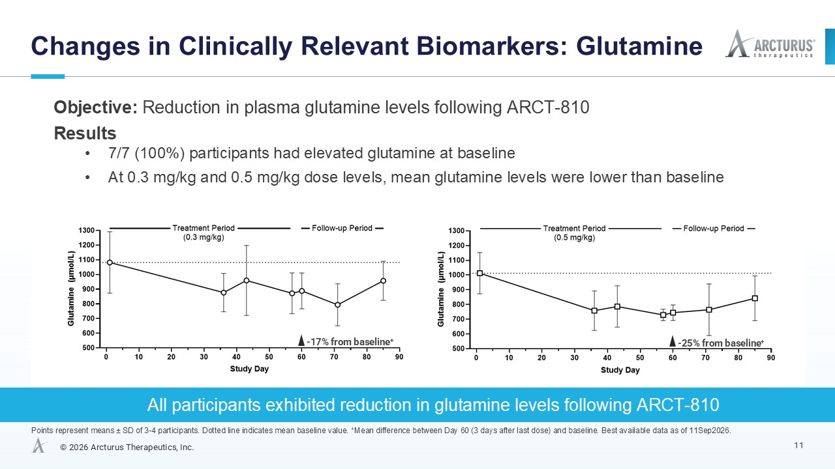

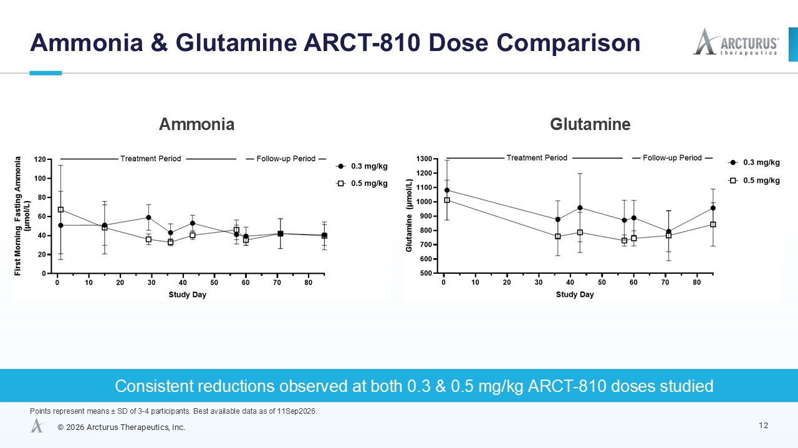

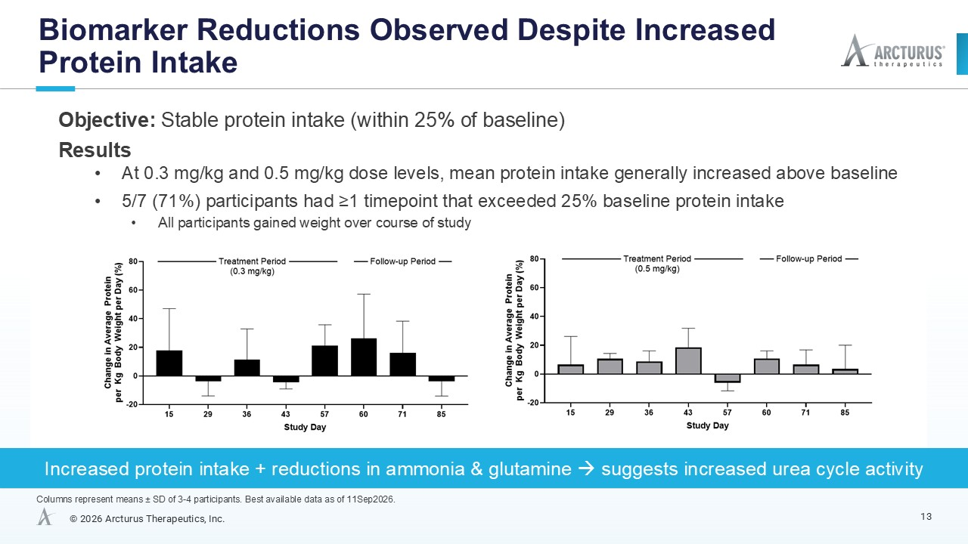

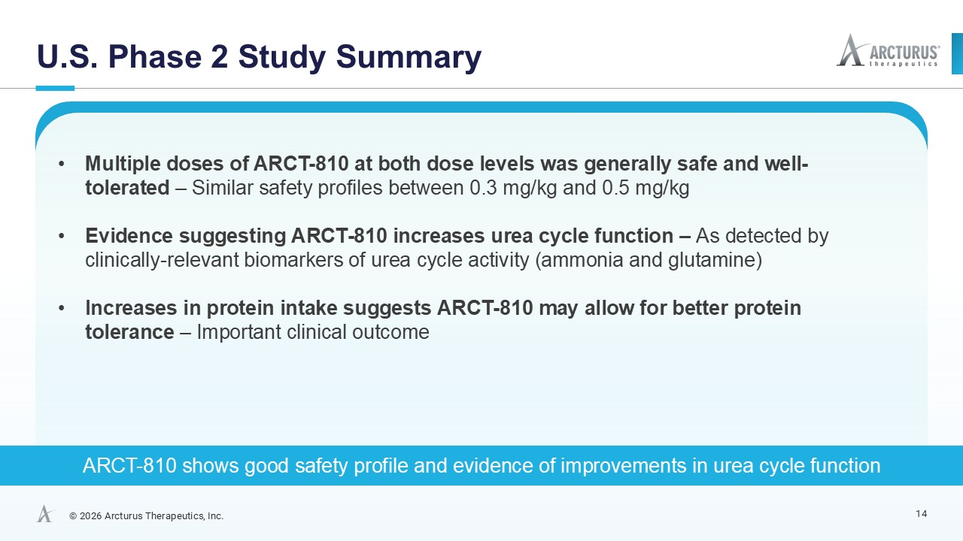

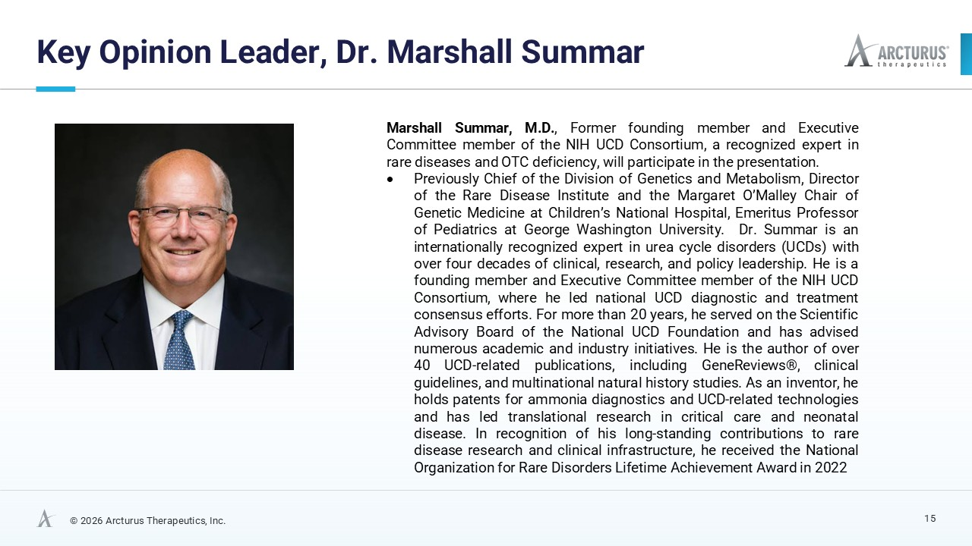

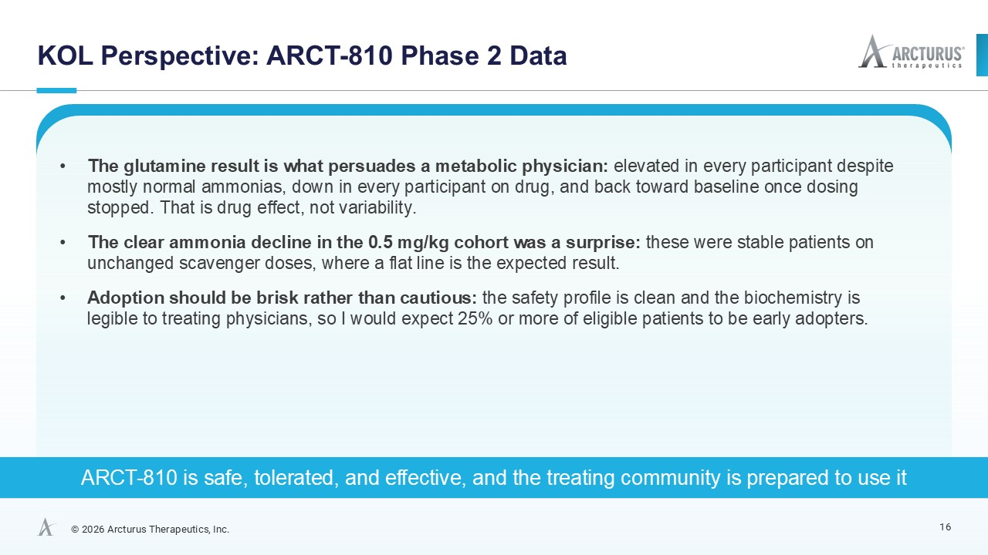



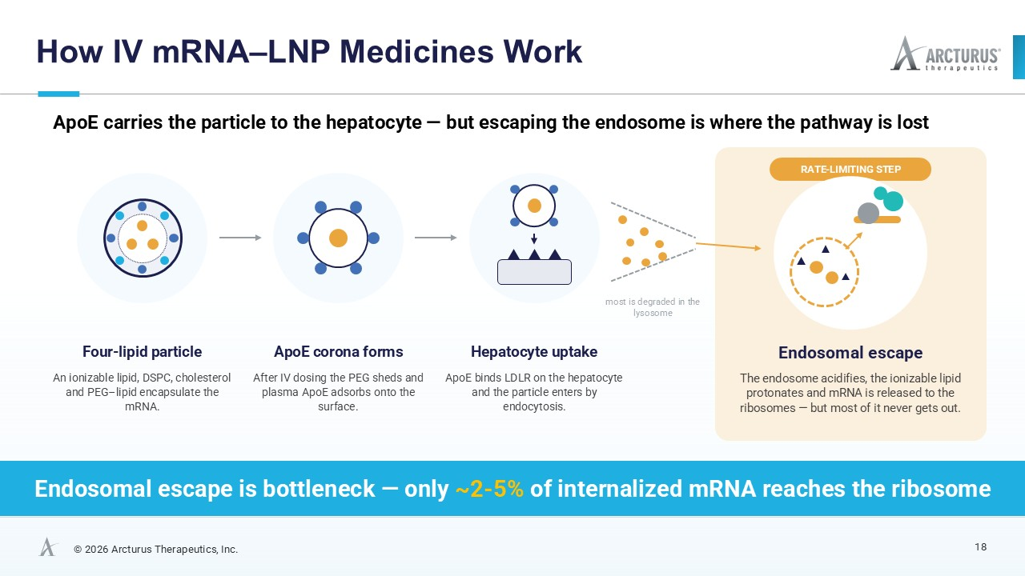

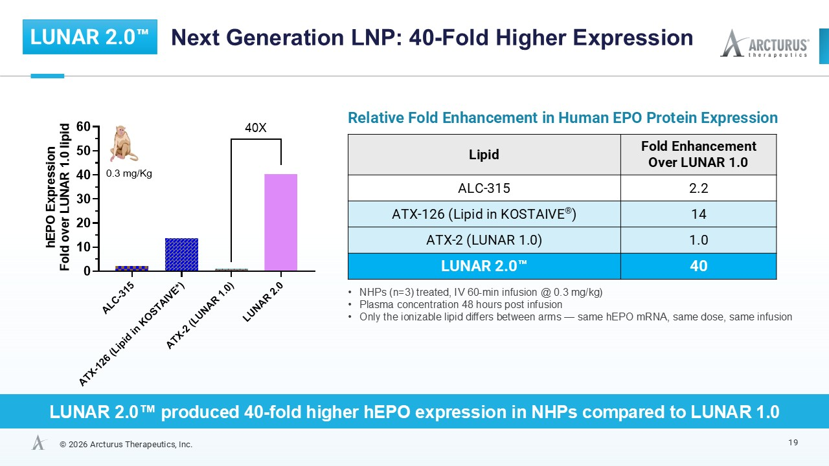

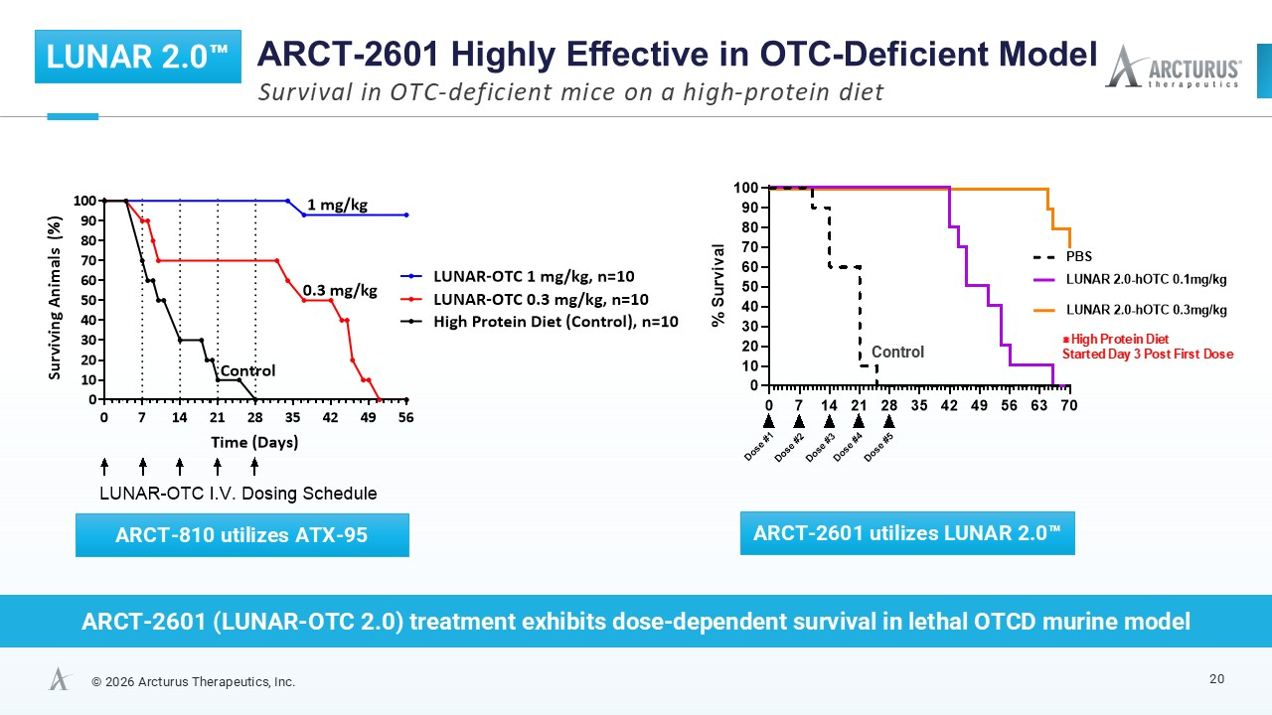

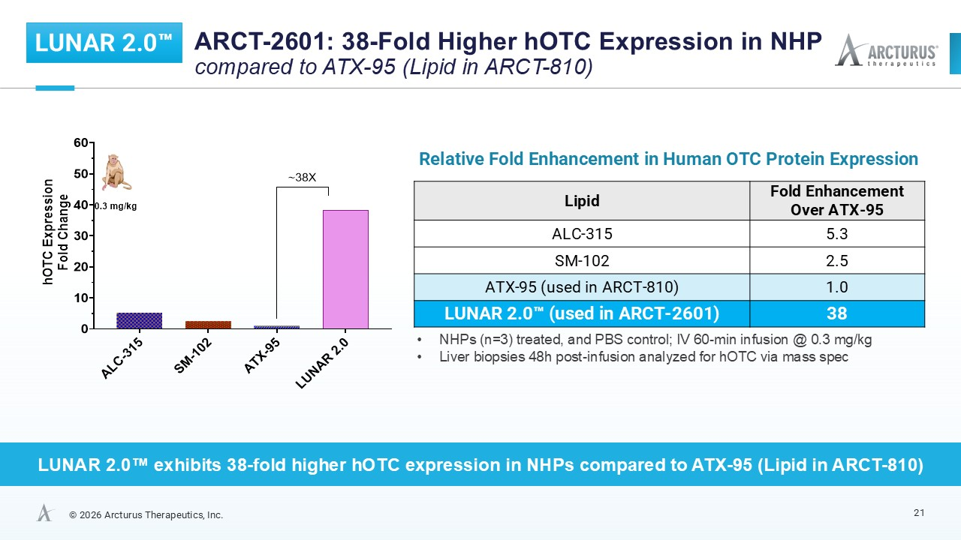

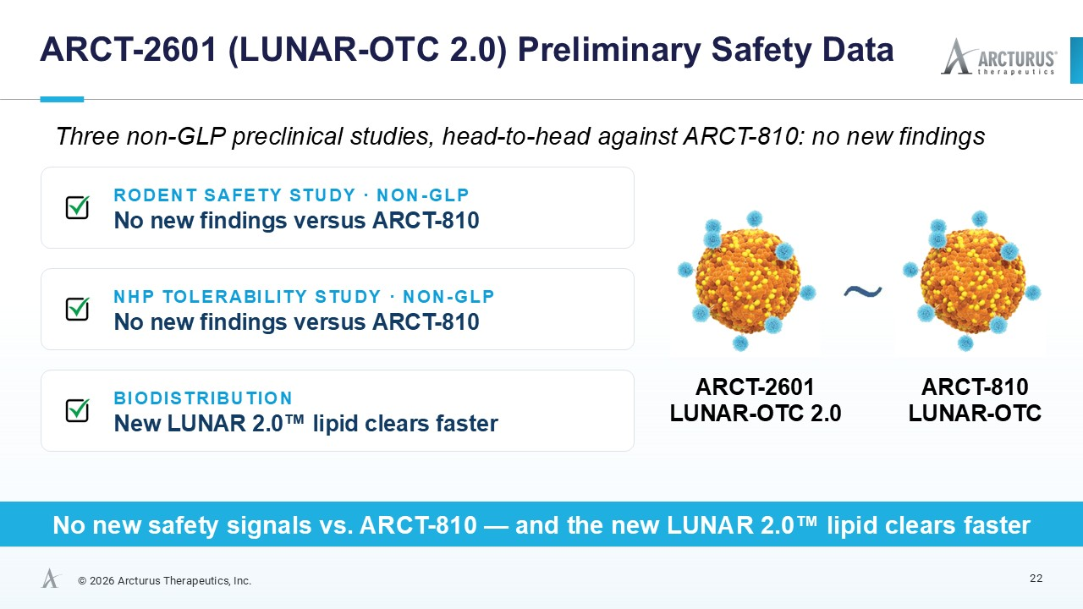

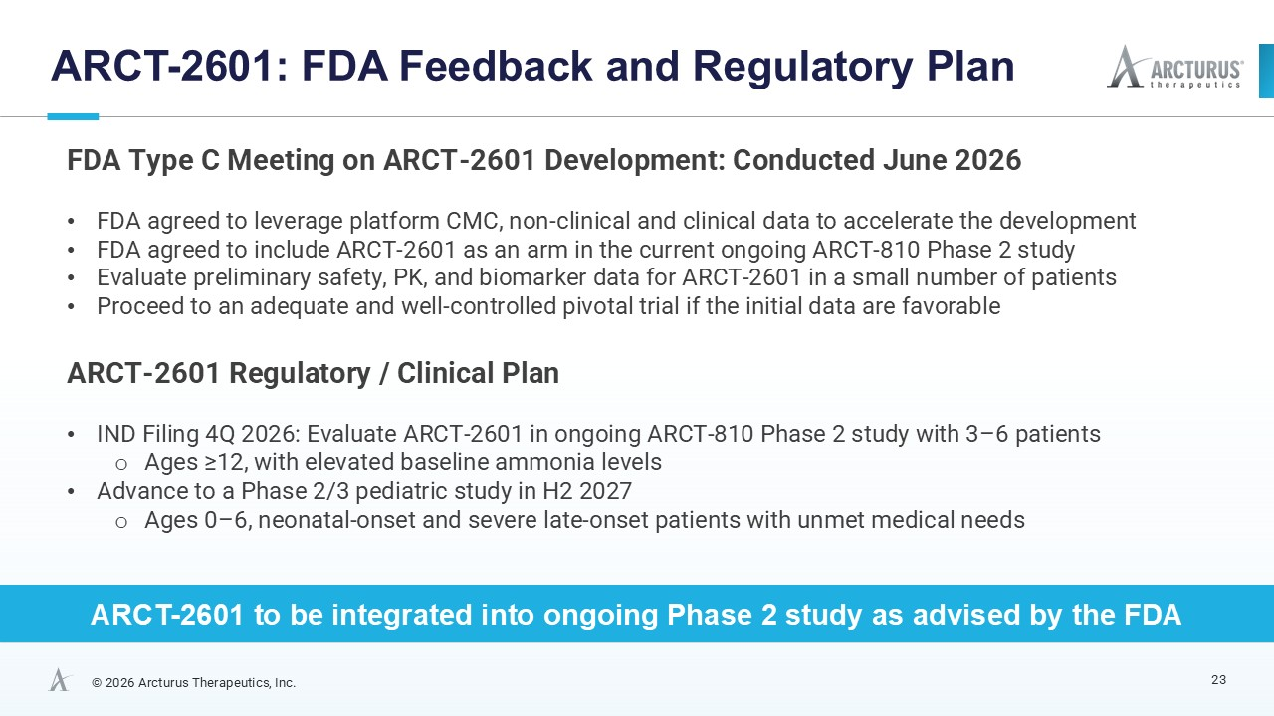

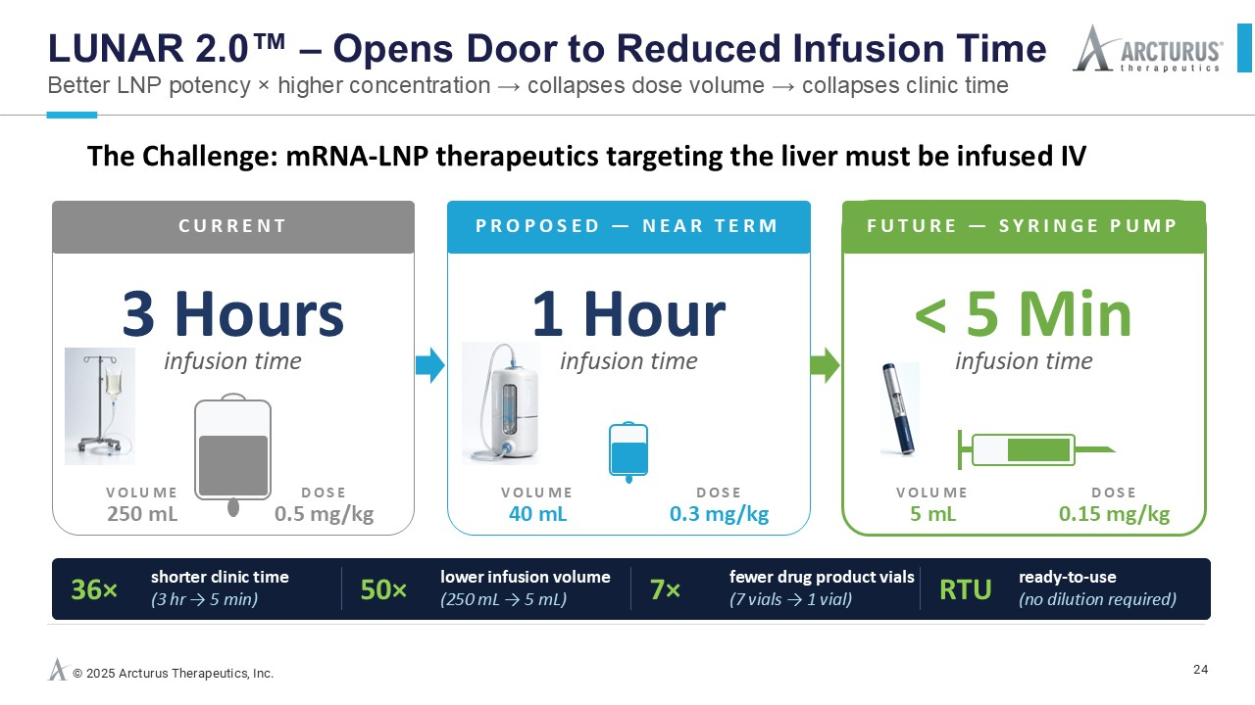

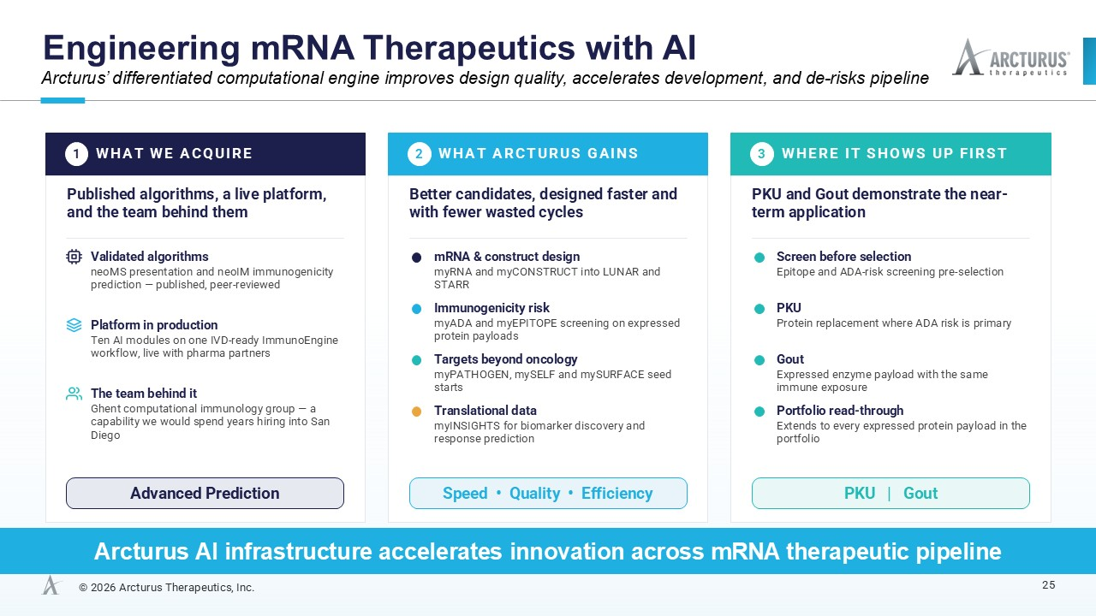

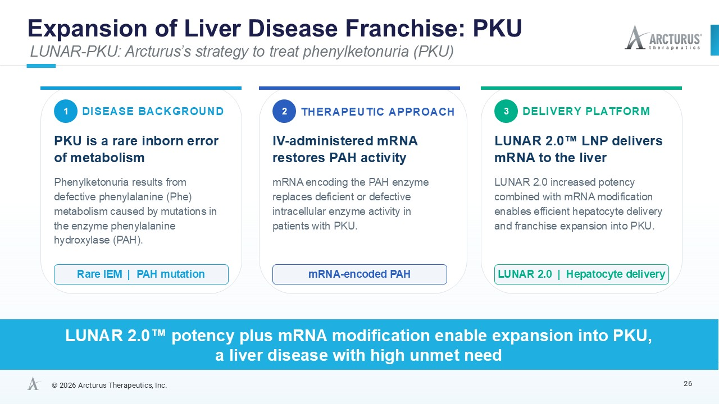

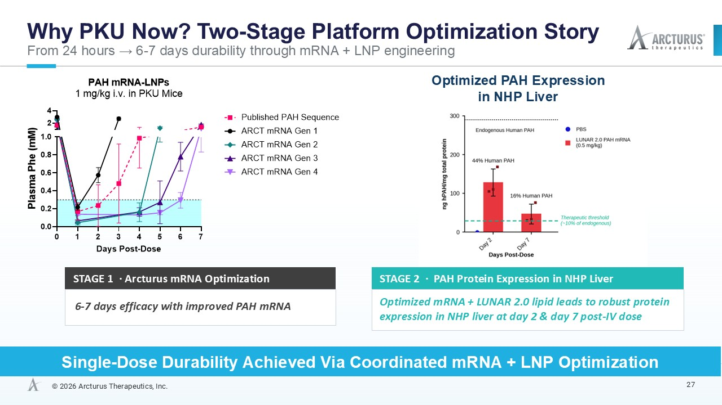

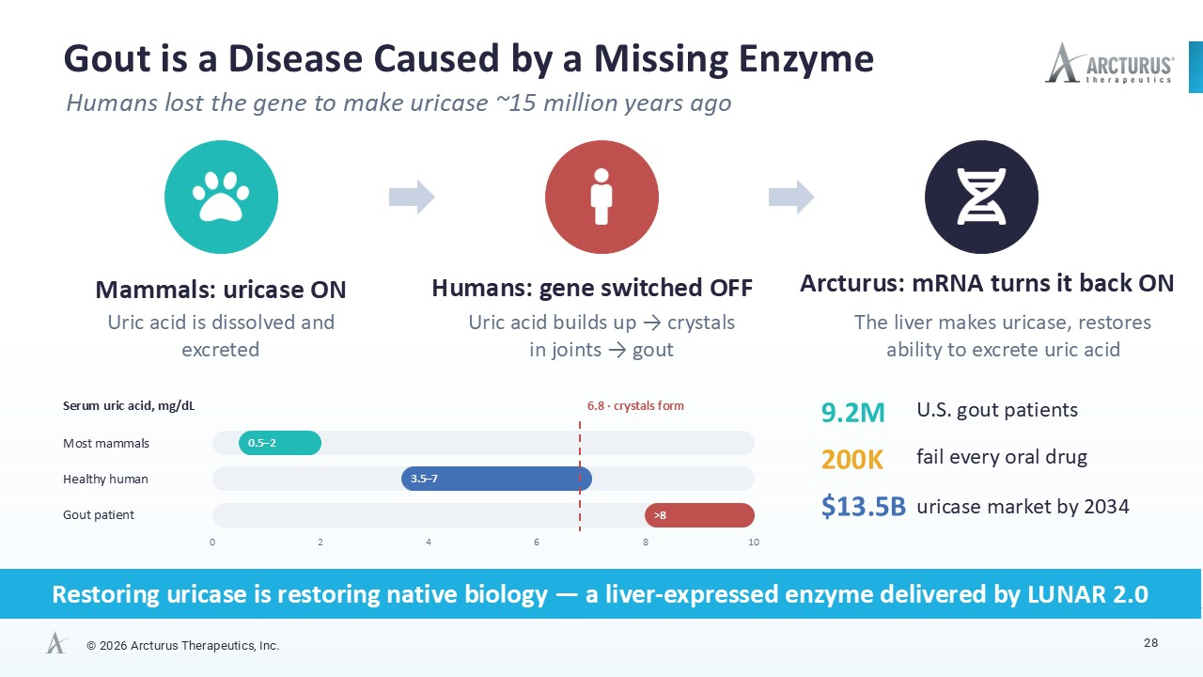

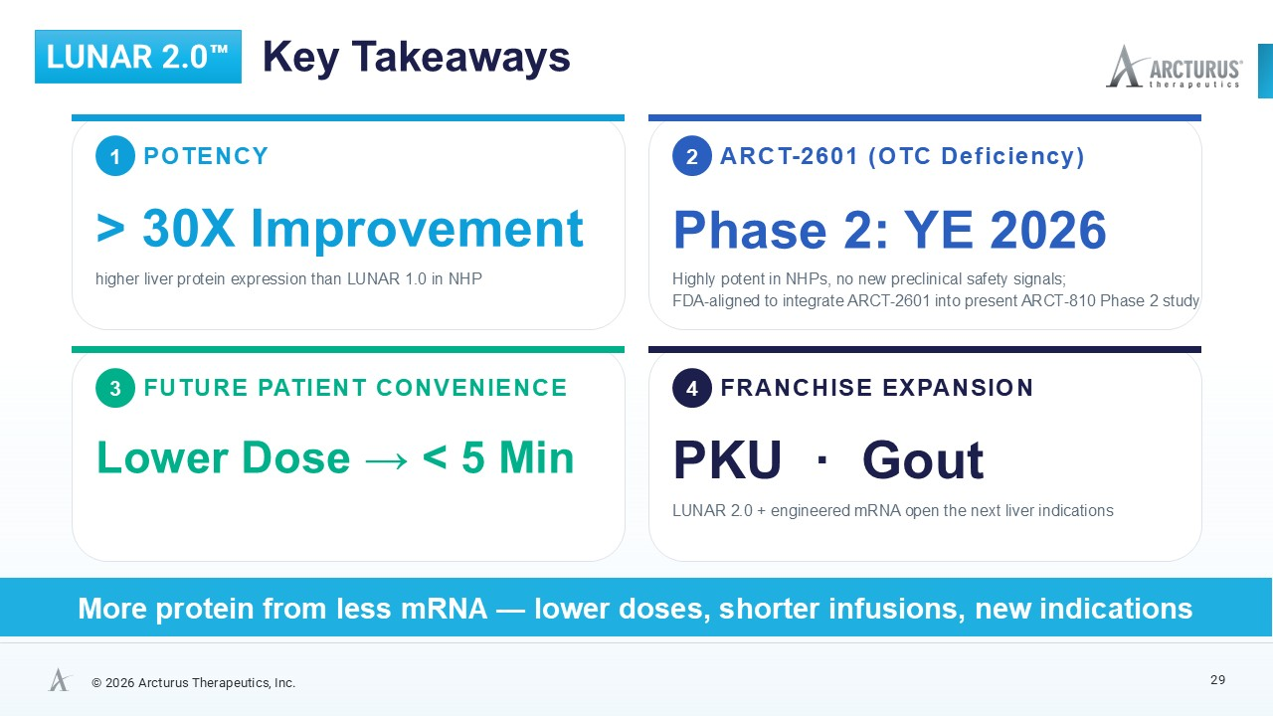

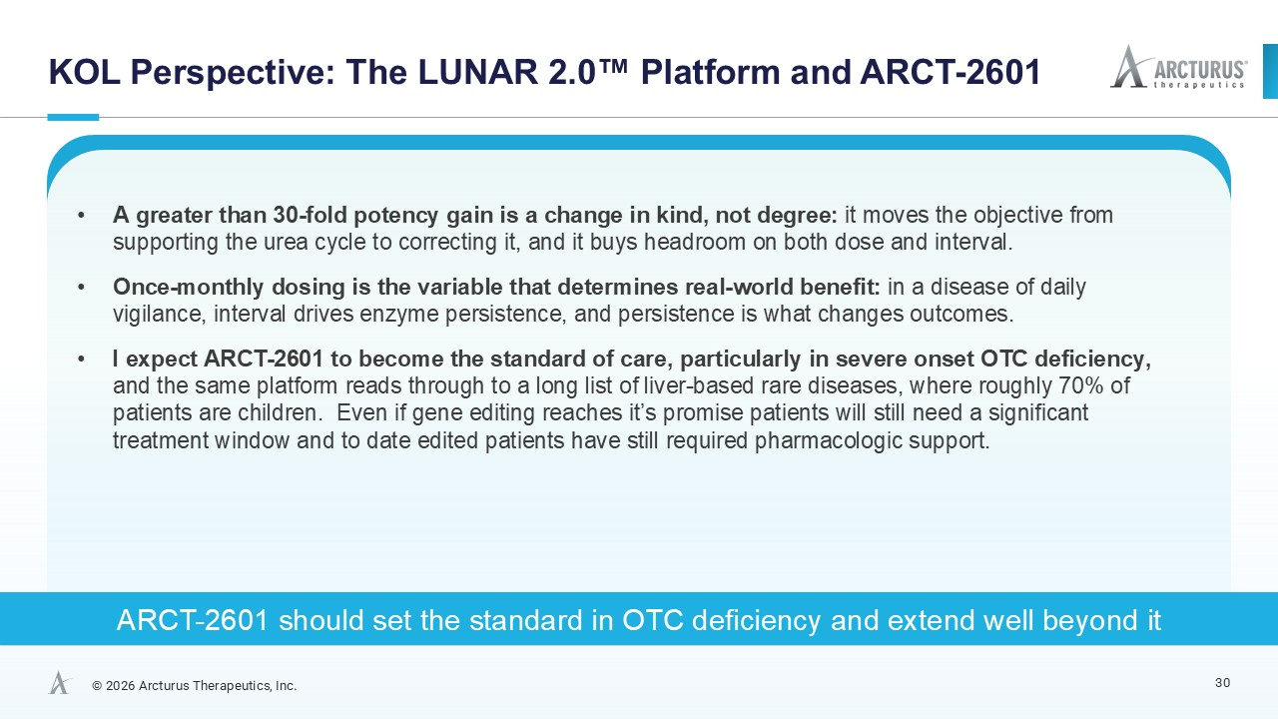



Arcturus Therapeutics Announces Interim OTC Deficiency Phase 2 Results and Introduces LUNAR 2.0™ Next-Generation mRNA Delivery Platform

ARCT-810 generally safe and well tolerated, demonstrating encouraging activity across key urea cycle biomarkers in ongoing Phase 2 study

LUNAR 2.0™ produces greater than 30-fold higher protein expression in multiple NHP studies – unlocks new therapeutic opportunities

ARCT-2601, an OTC deficiency therapeutic candidate utilizing LUNAR 2.0™, to be integrated by YE 2026 into ongoing Phase 2 study as advised by the FDA

Arcturus to acquire myNEO, an AI discovery company, to improve mRNA design quality, accelerate innovation, and enhance target identification capability

Presentation at 4:30 p.m. ET today

SAN DIEGO--(BUSINESS WIRE)--September 23, 2026--Arcturus Therapeutics Holdings Inc. (the “Company,” “Arcturus,” Nasdaq: ARCT), a messenger RNA medicines company focused on the development of liver and respiratory therapeutics, today announced encouraging interim Phase 2 results from ARCT-810 in ornithine transcarbamylase (OTC) deficiency and introduced LUNAR 2.0™, the Company’s next-generation mRNA delivery platform, and additional liver pipeline programs.

“The ARCT-810 Phase 2 interim results validate Arcturus’ mRNA liver therapeutics platform and the introduction of LUNAR 2.0™ marks the beginning of a new and exciting chapter for Arcturus,” said Joseph Payne, President and CEO of Arcturus. “We are very pleased that ARCT-2601, utilizing LUNAR 2.0™, is positioned to be efficiently integrated into our ongoing OTC deficiency Phase 2 study later this year.”

“The greater than 30-fold improvement demonstrated by the next-generation platform is exciting and has the potential to translate into a more effective and more convenient therapy,” said Dr. Marshall Summar, former founding member and Executive Committee member of the NIH Urea Cycle Disorders Consortium, a recognized expert in rare diseases and OTC deficiency. “I believe ARCT-2601 has the potential to become a new standard of care for OTCD patients, particularly in severe onset, if approved, and I am excited to see the potential impact of Arcturus’ next-generation mRNA delivery platform across other programs.”

“Validating clinical data, a compellingly differentiated LUNAR 2.0™ mRNA delivery platform, and a proprietary AI computational engine, support the continued advancement of Arcturus’ growing mRNA therapeutics pipeline, including ARCT-2601, and the initiation of new programs, such as Phenylketonuria (PKU) and Gout,” said Dr. Pad Chivukula, Chief Scientific Officer of Arcturus.

ARCT-810 Phase 2 Interim Results

 | • | Generally safe and well tolerated
 | • | Reduced and/or maintained first morning fasting ammonia within the normal range, including during increased protein intake by participants
 | • | Reduced glutamine, achieving normal range in some participants

In the Phase 2 study to date, ARCT-810 was generally safe and well tolerated, reduced and/or maintained first morning fasting ammonia within the normal range, including during increases in protein intake by participants; reduced glutamine, with participants at the 0.5 mg/kg dose level achieving mean glutamine values within the normal range during treatment. Weight gain was observed in all participants.

LUNAR 2.0™

LUNAR 2.0™ is the Company’s next-generation mRNA delivery platform that incorporates improved lipids and an enhanced formulation process specific to these lipids. In non-human primates (NHPs), LUNAR 2.0™ demonstrated a 40-fold improvement compared to LUNAR 1.0 in expressing human erythropoietin (hEPO). In a separate NHP study, LUNAR 2.0™ exhibited 38-fold more potency than ATX-95, the key lipid in ARCT-810, in expressing human ornithine transcarbamylase (hOTC). LUNAR 2.0™ unlocks new therapeutic opportunities previously inaccessible, including Phenylketonuria (PKU) and Gout.

ARCT-2601 Utilizes LUNAR 2.0™

ARCT-2601 is Arcturus’ next-generation investigational mRNA therapeutic for OTCD. To date, ARCT-2601 has demonstrated a similar safety profile to ARCT-810 in non-GMP pre-clinical studies. The U.S. Food and Drug Administration provided favorable feedback and regulatory-path clarity for ARCT-2601, following a Type C meeting in June this year. Based on the data and the feedback from the FDA, Arcturus plans to initiate dosing of ARCT-2601 near year-end in participants with OTCD, ages 12 years and older, under an amended Phase 2 protocol that integrates ARCT-2601 into the current ARCT-810 Phase 2 study. Based on data in non-human primates, ARCT-2601 is anticipated to provide benefits of lower and/or less frequent dosing.

Arcturus to Acquire myNEO

Arcturus has entered into a definitive agreement to acquire myNEO, subject to customary closing conditions. The transaction is expected to close in October. Arcturus has been working closely with myNEO since 2024. The acquisition brings a differentiated computational engine, supported by proprietary intellectual property, intended to fortify Arcturus’ AI infrastructure by improving mRNA design quality and enhancing target identification capabilities.

Presentation: Today at 4:30 p.m. ET

 | • | Domestic: 1-800-347-6865
 | • | International: 1-203-518-9757
 | • | Conference ID: Arcturus
 | • | Webcast: Link

About Ornithine Transcarbamylase Deficiency

Ornithine transcarbamylase (OTC) deficiency is the most common urea cycle disorder. Urea cycle disorders are a group of inherited metabolic disorders of the liver that make it difficult for affected patients to remove toxic waste products as proteins are digested. OTC deficiency caused by mutations in the X-linked OTC gene, leads to a non-functional or deficient OTC enzyme and usually affects males more severely. OTC is a critical liver enzyme which catalyzes a metabolic process that converts toxic ammonia to urea that is excreted by the kidney. This conversion does not occur properly in patients with OTC deficiency and, aside from the risk of high ammonia levels, leads to increased blood concentrations of glutamine with low to normal levels of citrulline and increases in urine orotic acid. High blood ammonia levels in OTC deficiency may cause health crises with seizures, progressive neurocognitive impairment, coma, and death. Severe cases of OTC deficiency usually present early in life, but patients with less severe symptoms may be diagnosed as adolescents and adults. There is currently no cure for OTC deficiency, apart from liver transplant. However, liver transplantation comes with significant risks of surgical and postsurgical complications such as organ rejection, and recipients must take immunosuppressant drugs for the rest of their lives. The current standard of care for OTC deficiency patients is well-controlled but may not prevent chronic neurotoxic effects and is challenging to maintain, consisting of a low-protein diet, substitution of essential amino acids and treatment with nitrogen scavenging medications that keep the ammonia from rising to acutely toxic levels. These treatments do not address the underlying cause of disease. In Europe and the U.S., approximately 10,000 people have OTC deficiency.

About ARCT-810

ARCT-810 is an intravenously administered investigational mRNA therapeutic designed to express normal functional OTC enzyme in the liver of individuals with OTC deficiency. ARCT-810 has received Orphan Medicinal Product Designation and an approved pediatric investigation plan (PIP) from the European Medicines Agency (EMA), and Orphan Drug Designation, Fast Track Designation along with Rare Pediatric Disease Designation from the U.S. Food and Drug Administration (FDA) for the treatment of OTC deficiency. ARCT-810 is based on Arcturus’ proprietary mRNA design methodologies, lipid platform and manufacturing and formulation processes. ARCT-810 also utilizes Arcturus’ extensive and proprietary lipid library and employs the Company's LUNAR® delivery platform to deliver OTC mRNA to hepatocytes.

About ARCT-2601

ARCT-2601 is a next-generation intravenously administered investigational mRNA therapeutic designed to express normal functional OTC enzyme in the liver of individuals with OTC deficiency. ARCT-2601 incorporates LUNAR 2.0™ including improved lipids and an enhanced formulation process specific to these lipids that have demonstrated greater than 30-fold improvement compared with LUNAR 1.0 in nonhuman primate studies. ARCT-2601 is based Arcturus’ proprietary mRNA design methodologies, lipid platform and manufacturing and formulation processes.

About First Morning Fasting Ammonia as a Biomarker

Hyperammonemia is responsible for the neurocognitive morbidity associated with OTCD. Maintenance of normal ammonia levels or reduction in ammonia levels is therefore a key goal for OTCD therapeutics including ARCT-810. A post hoc analysis including >1,000 ammonia results from 114 patients with urea cycle disorder (UCD) who were enrolled in four short-term ammonia scavenger switchover studies, demonstrated that first morning fasting plasma ammonia is the least variable of ammonia measurements and fasting ammonia correlates well with ammonia AUC0-24, a predictor of risk of hyperammonemia crises in UCD patients (Lee et al., 2015).

About Glutamine as a Biomarker

Glutamine is an important biomarker used by clinicians to monitor urea cycle function in OTC deficient patients. Glutamine reflects the body’s nitrogen buffering capacity. In urea cycle disorders, excess nitrogen is initially incorporated into glutamine, allowing glutamine to rise steadily as a compensatory mechanism before ammonia levels begin to spike. This role makes glutamine a more stable and predictive biomarker in patients who are not experiencing hyperammonemia. Glutamine assessments have significantly lower intra-subject variability than ammonia (15% vs. 56%), making it more reliable for monitoring metabolic control in stable conditions (Lee et al., 2016).

About Arcturus

Founded in 2013 and based in San Diego, California, Arcturus Therapeutics Holdings Inc. (Nasdaq: ARCT) is a messenger RNA medicines company focused on the development of liver and respiratory therapeutics with enabling technologies: (i) LUNAR® lipid-mediated delivery, (ii) STARR® mRNA technology (sa-mRNA) and (iii) mRNA drug substance along with drug product manufacturing expertise. Arcturus developed KOSTAIVE®, the first self-amplifying messenger RNA (sa-mRNA) COVID vaccine in the world to be approved. Arcturus’ strategic collaborations include Thermo Fisher Scientific for ARCT-032 manufacturing and development, BARDA for pandemic influenza initiatives, and ARCALIS, a Japanese joint venture focused on manufacturing mRNA vaccines and therapeutics. Arcturus’ pipeline includes programs in cystic fibrosis (CF), ornithine transcarbamylase (OTC) deficiency, phenylketonuria (PKU) and Gout. Arcturus’ versatile RNA therapeutics platforms can be applied toward multiple types of nucleic acid medicines including messenger RNA, small interfering RNA (siRNA), circular RNA, antisense RNA, self-amplifying RNA, DNA, and gene editing therapeutics. Arcturus’ technologies are covered by its extensive patent portfolio (over 500 patents and patent applications in the U.S., Europe, Japan, China, and other countries). For more information, visit www.ArcturusRx.com. Please connect with us on X and LinkedIn.

Forward Looking Statements

This press release contains forward-looking statements that involve substantial risks and uncertainties for purposes of the safe harbor provided by the Private Securities Litigation Reform Act of 1995. Any statements, other than statements of historical fact included in this press release, are forward-looking statements, including those regarding strategy, future operations, the likelihood of success of the Company’s pipeline (including ARCT-810 and ARCT-2601), the likelihood that the interim results of ARCT-810 Phase 2 will be predictive of future clinical results, the likelihood that preclinical data, including the data generated for ARCT-2601, will be predictive of future preclinical or clinical results, the continued advancement of the Company’s OTC deficiency program or ARCT-2601, the potential of LUNAR 2.0 to enable the Company to pursue other therapeutic opportunities, the likelihood that the Company will advance new programs with LUNAR 2.0 such as PKU or Gout, the Company’s plan to integrate ARCT-2601 into the Phase 2 study and the timing therefor, the potential effectiveness and dosing interval of ARCT-2601, the potential of ARCT-2601 to become a new standard of care, the relative significance or predictiveness of different biomarkers, the likelihood that ARCT-2601 will provide benefits of lower and/or less frequent dosing, the anticipated closing of the acquisition of myNEO and the timing therefor, and the impact of general business and economic conditions. Arcturus may not actually achieve the plans, carry out the intentions or meet the expectations or projections disclosed in any forward-looking statements such as the foregoing and you should not place undue reliance on such forward-looking statements. These statements are only current predictions or expectations, and are subject to known and unknown risks, uncertainties, and other factors that may cause our or our industry’s actual results, levels of activity, performance or achievements to be materially different from those anticipated by the forward-looking statements, including those discussed under the heading "Risk Factors" in Arcturus’ most recent Annual Report on Form 10-K, and in subsequent filings with, or submissions to, the SEC, which are available on the SEC’s website at www.sec.gov. Except as otherwise required by law, Arcturus disclaims any intention or obligation to update or revise any forward-looking statements, which speak only as of the date they were made, whether as a result of new information, future events or circumstances or otherwise.

Contacts

Arcturus Therapeutics
Public Relations & Investor Relations
Neda Safarzadeh
VP, Head of IR/PR/Marketing
(858) 900-2682
IR@ArcturusRx.com

